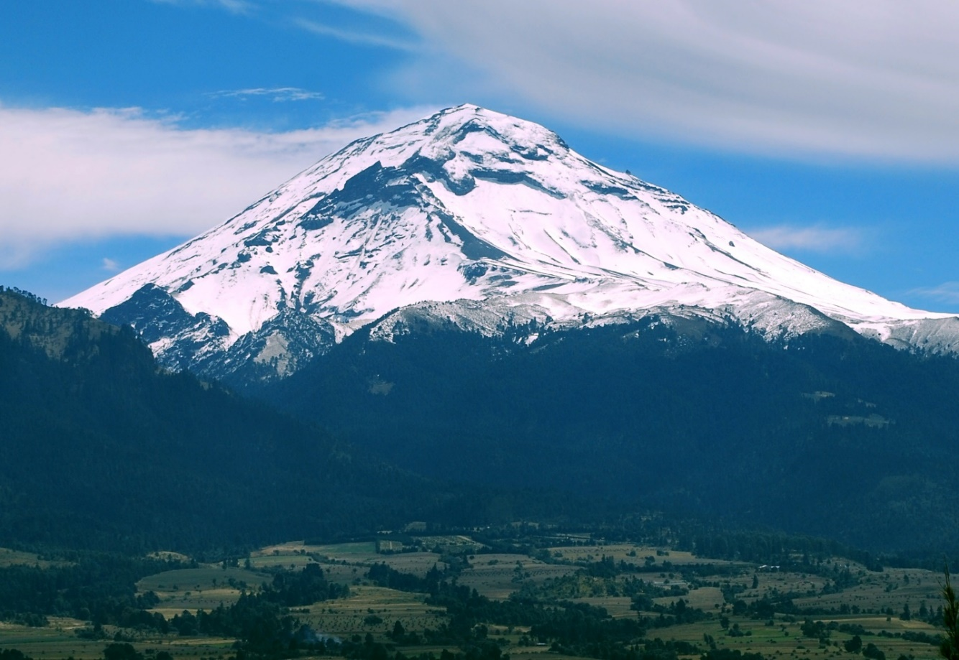
Popocatépetl or Popo volcano in Mexico
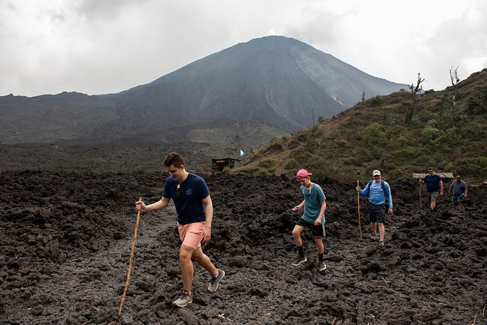
Volcán Pacaya in Guatemala
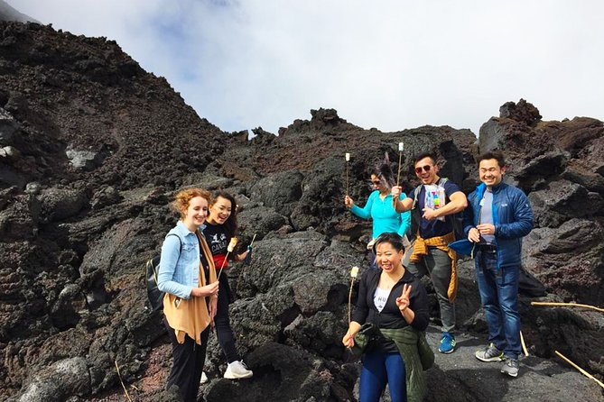
Tourists roasting marshmallows on Volcán Pacaya in Guatemala
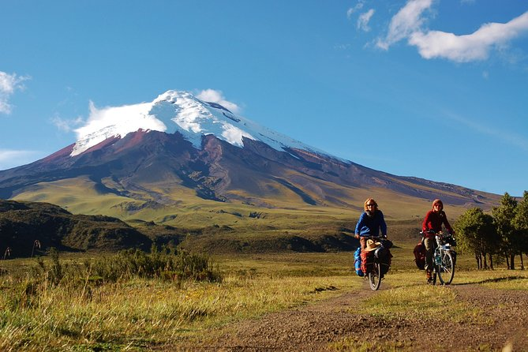
Cotopaxi in Ecuador
