Me llamo___________________________________
Week 4 Optional Homework: Vamos a Explorar
¡Me encanta el museo! (I love the museum!)
Directions: Look at the pictures of the items below. Match them to the vocabulary words in Spanish from the word list below by drawing a line to connect them. Use your newsletters to help!
El museo, el arte, el boleto, el mercado, la artesanía
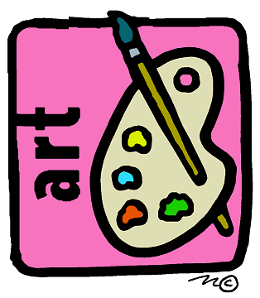
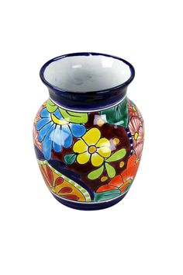
¿Te encantas? (Do you love it?)
Directions: Write three sentences to describe the items you love from the class vocabulary in Spanish using the phrase “Me encanta____.”Note: You can use vocabulary from previous weeks as well. For example: Me encanta la ciudad. I love the city.
Tell a friend or family member the three sentences orally in Spanish.
- _________________________________ .
- __________________________________.
- __________________________________.
Futura Language Professionals · www.futuraadventures.com

