Me llamo___________________________________
Week 7 Optional Homework: Draw a line from the image on the left to its Spanish name on the right, using Dani’s journal entry below for clues.
“Querido diario (Dear diary),
Today, on our excursión to la selva, we not only saw animales like monos and serpientes, but also plantas-- like café and flores! Our guía showed us the way and we learned a lot from her. What an adventure!
¡Chau! (Bye!)”

el serpiente
el mono

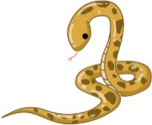 la planta del café

la selva

la guía

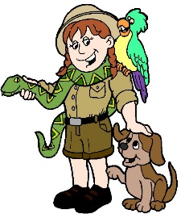 la flor
Futura Language Professionals · www.futuraadventures.com

