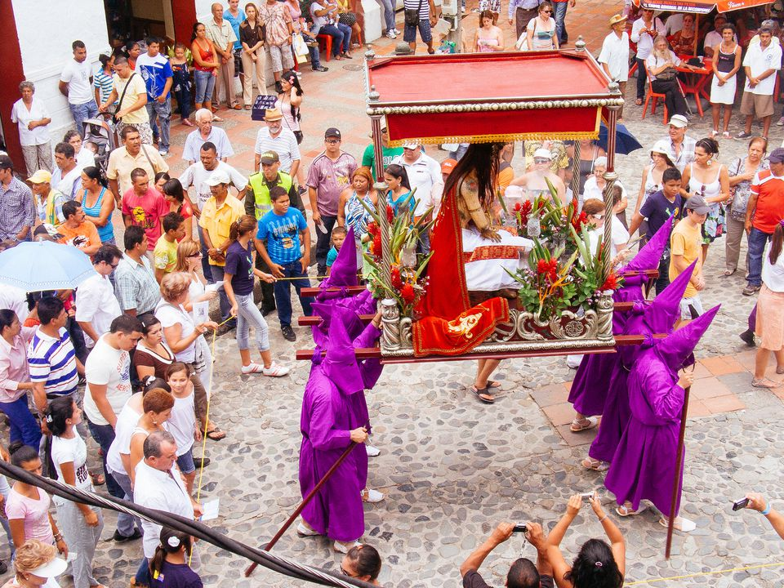**La Semana Santa**

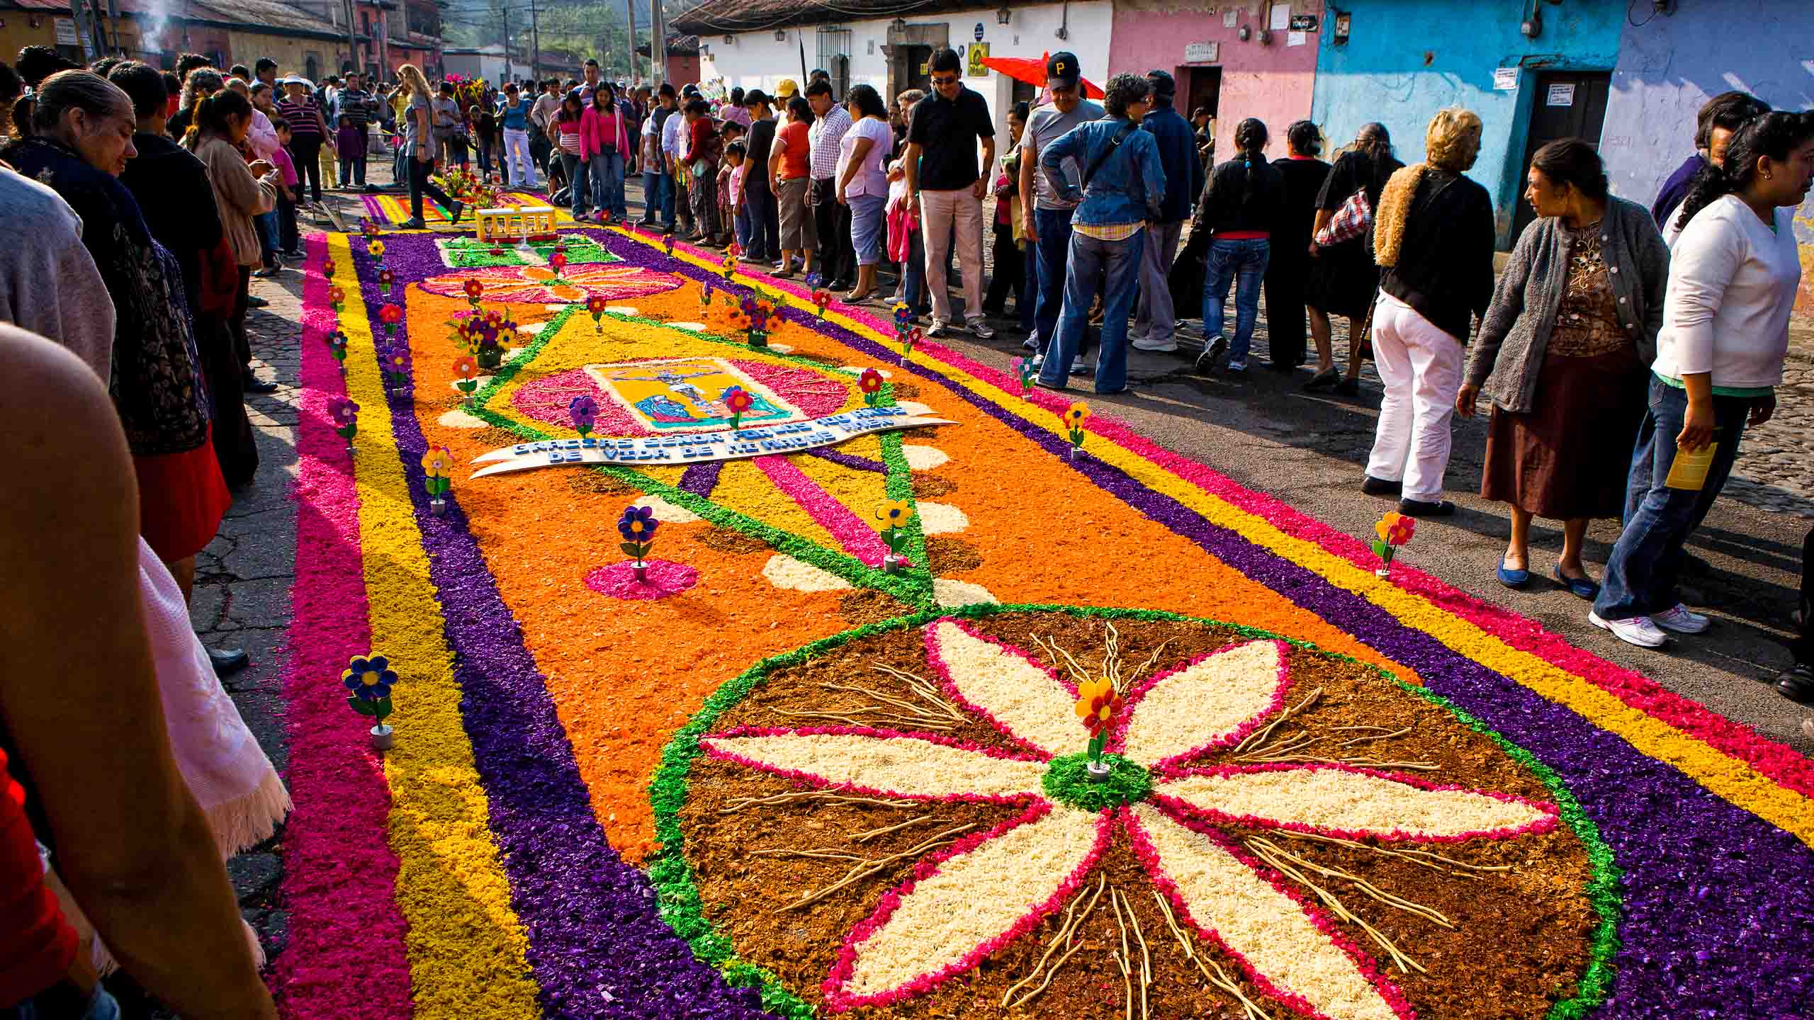

[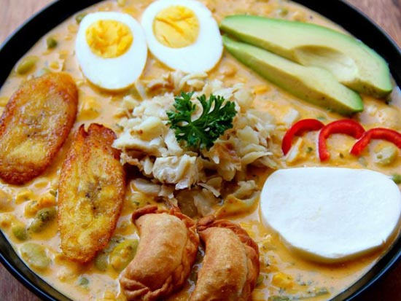](https://www.google.com/url?sa=i&rct=j&q=&esrc=s&source=images&cd=&cad=rja&uact=8&ved=0ahUKEwiOlbOpoZTZAhUKmVkKHUK2CmEQjRwIBw&url=http://www.terradiversa.com/tour/cooking-fanesca-in-cuenca/&psig=AOvVaw3BF2W6o5sgoLNq2ilyGA6T&ust=1518108582551403)

**Fanesa**

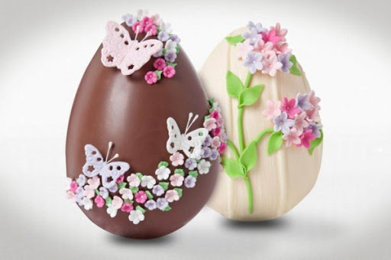

**Chocolate eggs in Argentina**

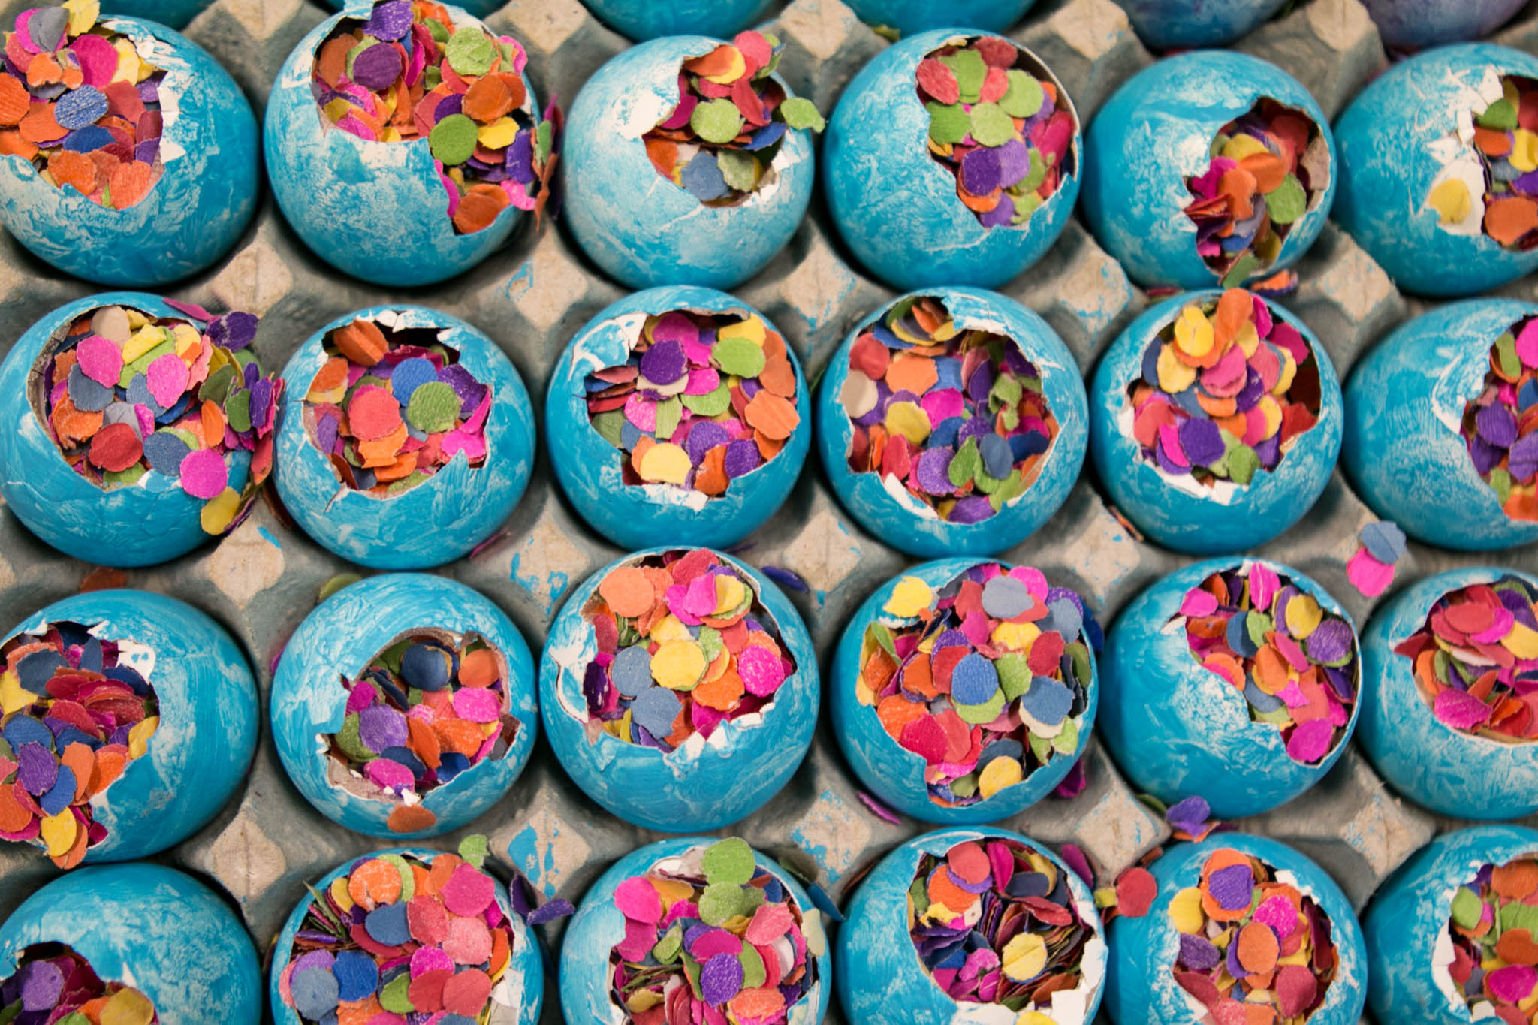

**Cascarones**

