Semana - Week | Fecha - Date
Semana 5 – Week 5

- La Gramática – Grammar:
¿El o la? Gender of Spanish Nouns
- Gender can be determined by word meaning. The word for “man” will be masculine; for “woman” will be femenine: El hombre/la mujer. Some words that are otherwise very similar will change the article and sometimes shift slightly in spelling to reflect gender: el estudiante/la estudiante, el profesor/la profesora.
- Languages, rivers, oceans, days of the week and months of the year are masculine
- Often, words ending in d, ión, z and a are femenine. These are sometimes referred to as “DIONZA” (d-ión-z-a) words to help you remember which endings are often (but not always!) femenine. So DIONZA, (d-ión-z-a) endings are Femenine
- Often (but not always!), words ending in “ LONER” (l,o,n,e,r) are masculine. These may be referred to as “loner” words to help you remember the key endings.
So LONER (l-o-n-e-r) endings are maculine
- Remember that definite & indefinite articles (el , la, los las, un, uno, unas, unos, etc) also singular or plural have to match the noun in masculine or feminine. Ej. La casa, las casas, el parque, los parques, etc.

- El Vocabulario – Vocabulary: Food and Dining
Builder Phrases: Dining Out
- ¿Cuanto cuesta? How much is it? ¿Cuanto cuestan? How much are they?
- ¿Que le gustaría para comer? What would you like to eat?
- Me gustaría… I would like… Me gusta… I like… No me gusta… I don’t like…
- ¿Tiene? Do you have? Que tiene para….? What do you have for….?
- Que rico! Delicious! Bueno Good Malo Bad (as it refers to food)
- ¿Hay….? Is/Are there any….? ¿No hay? There is not…?
- La cuenta por favor? The check please? Cuanto es? How much it is?
- Precio Price, Costo Cost, Cambio exchange, descuento discount
- Pago en efectivo Pay with cash, Pago con tarjeta de crédito Pay with credit card
- Buen provecho/ Provecho Enjoy your meal.
- Vamos a desayunar, comer, cenar Let’s go to have breakfast, lunch, dinner,
- Tengo hambre I’m hungry
- Por favor Please, Gracias thank you

Comida | Food
el desayuno | breakfast
la comida | lunch
la cena | dinner
la bebida | drink
el postre | dessert
los huevos | eggs
el bocadillo/ snack | snack
el pan | bread
el sándwich | sandwich
las papas fritas | chips
las papas a la francesa | french fries
las verduras | vegetable
la fruta | fruit
la sopa | soup
la ensalada | salad
el bistec | beef
el pollo | chicken
el pescado | fish
el arroz | rice
los frijoles | beans
el café | coffee
el jugo | juice
la cerveza | beer
el agua | water
la leche | milk
el helado | ice cream
el restaurante | restaurant
y | and
con | with
para llevar | to go
el dolar | dollar
el centavo | cents
el cambio o feria | change or money fair

- Los Numeros – Numbers
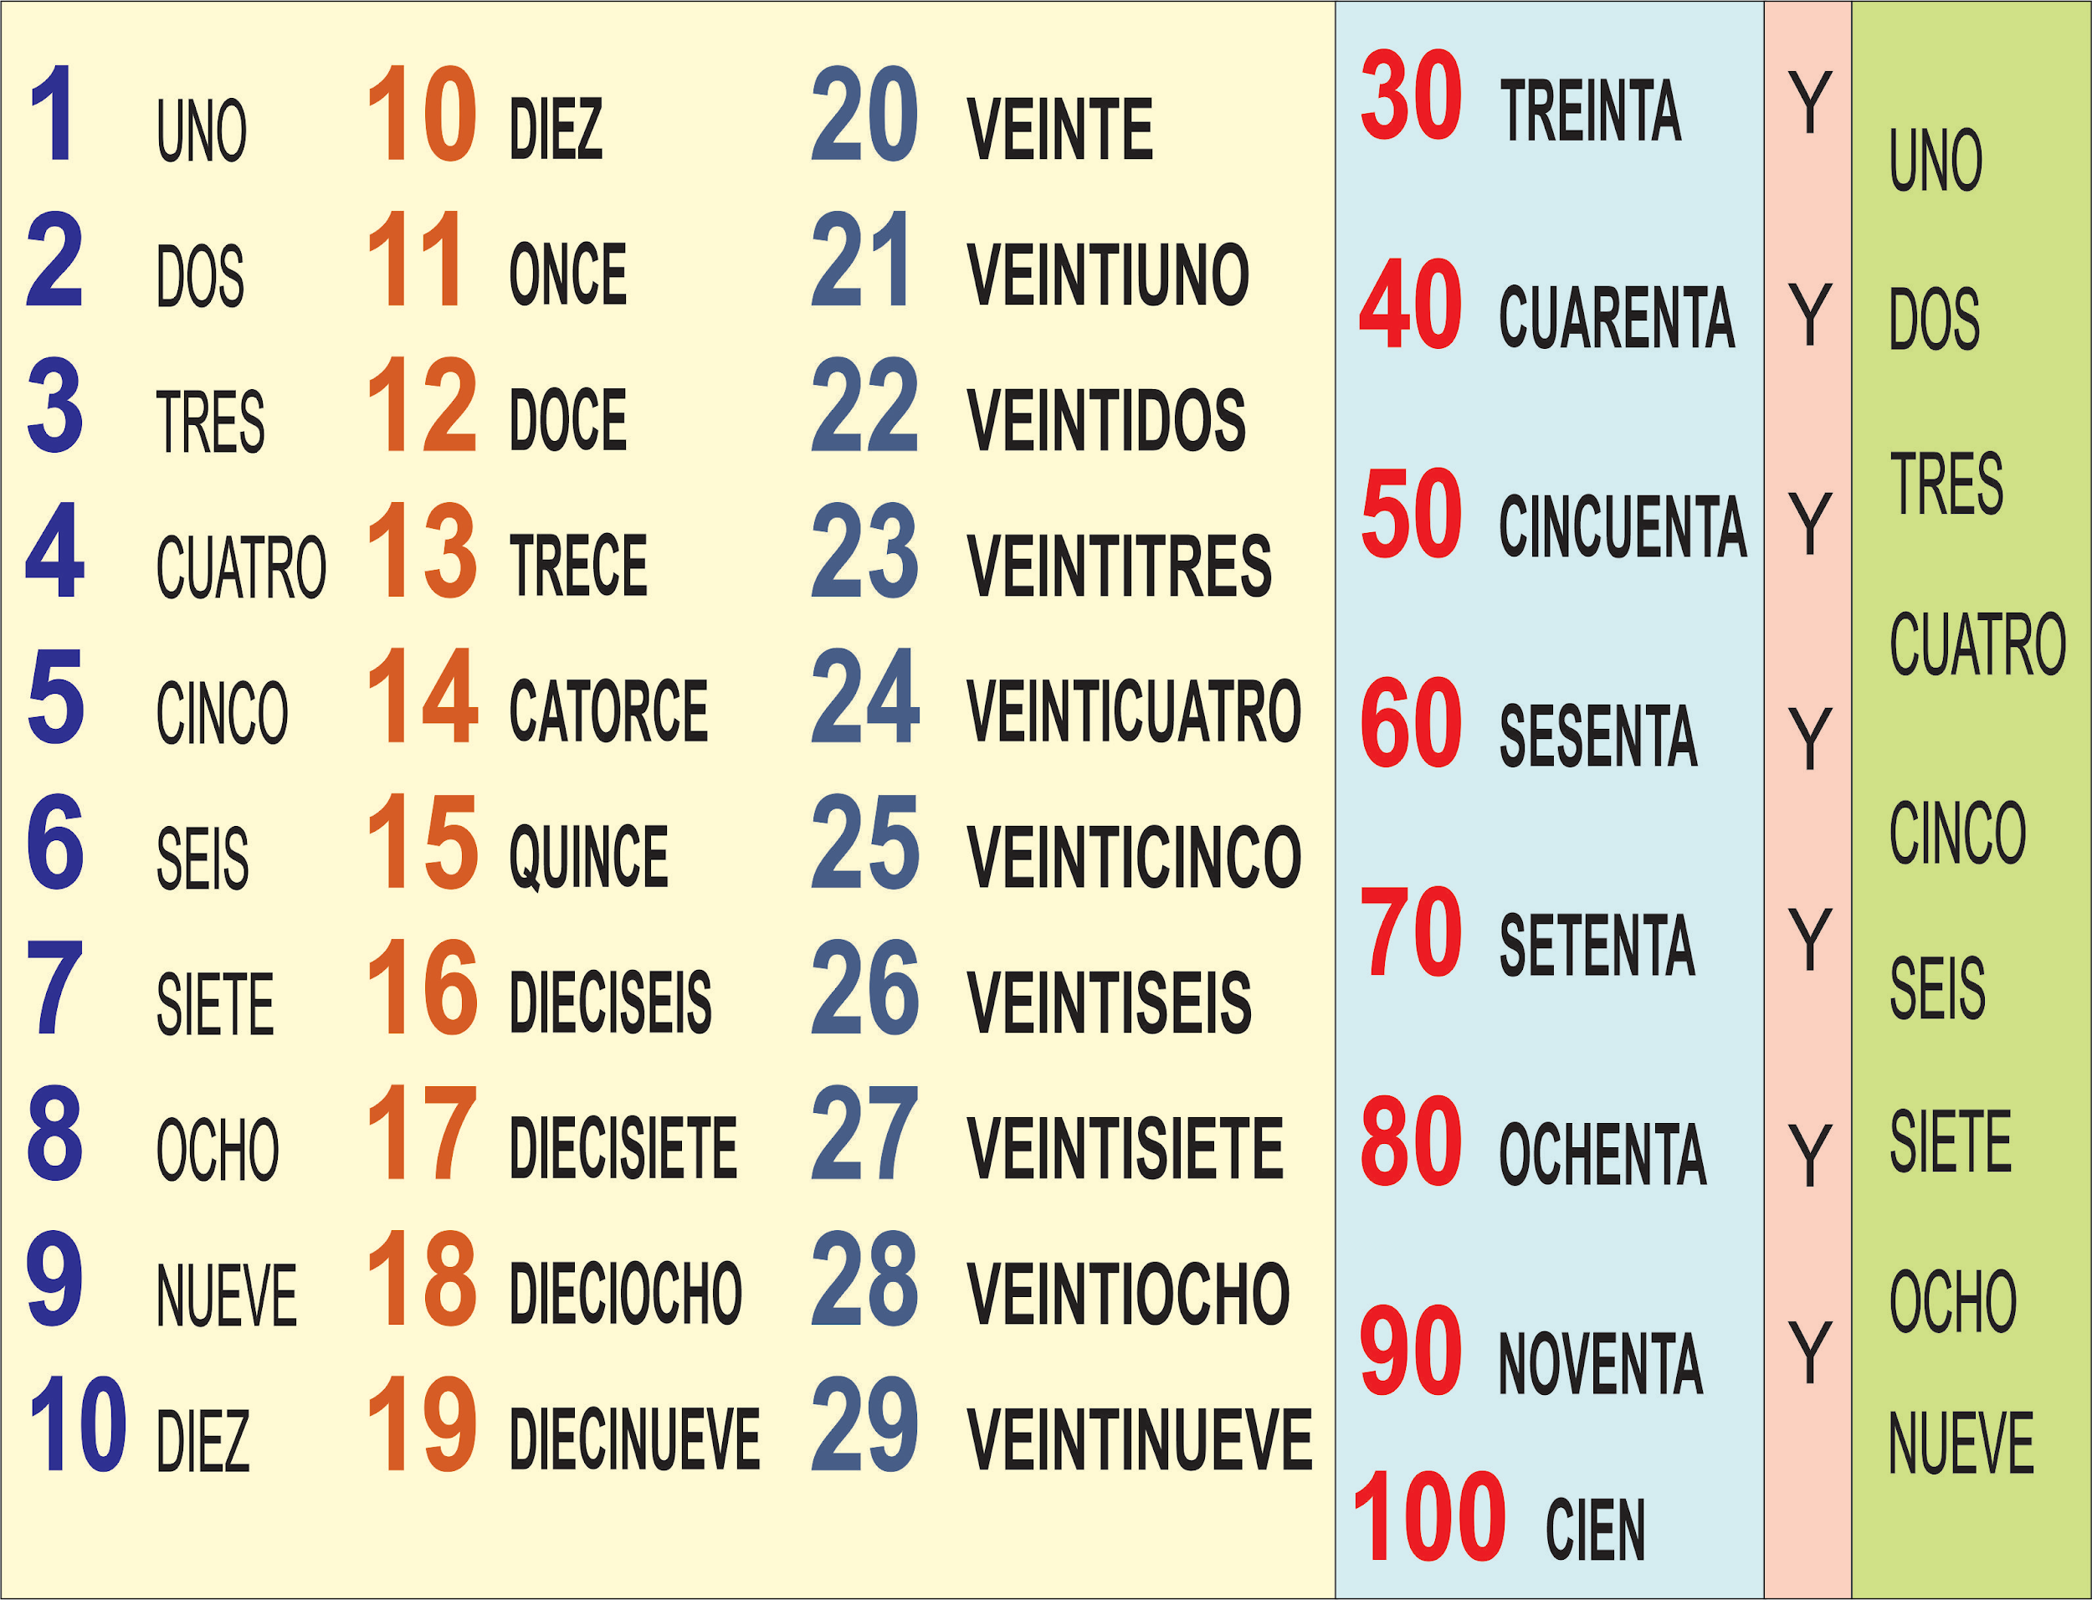

- El Vocabulario – Vocabulary: Clothing
Builder Phrases:
- ¿Tiene … en talla....? Do you have….in size….?
- ¿Cuanto cuesta? How much is it? ¿Cuánto cuestan? How much are these?
- Grande Large Mediano medium Chico small
- ¿Que colores tiene? In what colors do you have? Color color
- ¿Dónde está el probador? Where is the fitting room?
- Me queda ..(chico, grande) It is..(small, big) for me
- Me dá …. Por favor, Give me …. please

La ropa | The clothes
la falda | skirt
la camisa (for men) | shirt
la blusa (for women) | blouse
la camiseta/ playera | T-shirt
la chamarra/chaqueta (except in mexico) | jacket
abrigo | coat
el vestido | dress
el gorro/ el sombrero | hat
los zapatos | shoes
los tenis | shoes
las sandalias | sandals
los guantes | gloves
los pantalones | pants
los shorts (pantalones cortos) | shorts
los calcetines | socks
el traje de baño | swimsuit
la bolsa | purse

