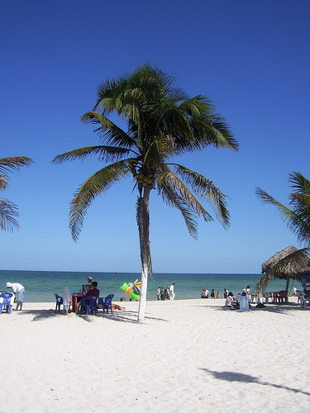 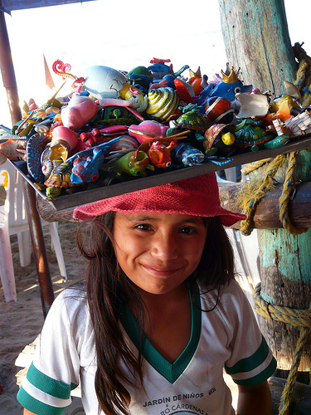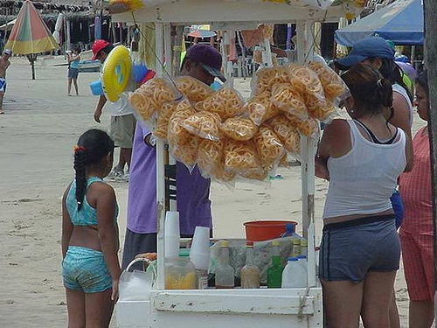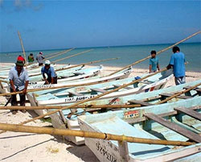

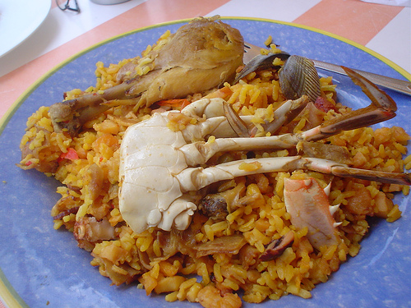

**Arroz estillo del mar**rice with fresh seafood Mérida, Mexico.

[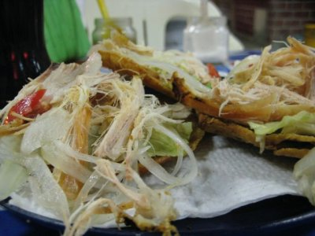](http://www.travellerspoint.com/photos/stream/size/L/photoID/384106/tags/food/)  
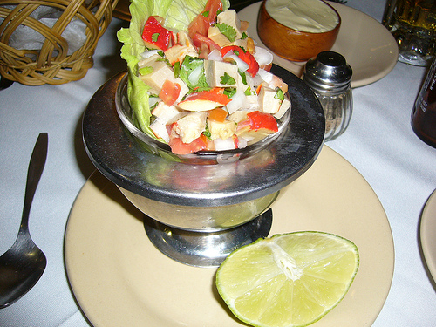

**Ceviche-**Cold seafood with lime and cilantro

Mérida, Mexico.

**Panuchos**Bean-filled, chicken-topped tortillas (panuchos) from a stand in Parque Santiago, Mérida, Mexico.

**Arroz estila del mar-**Rice with fresh seafood

Mérida, Mexico.