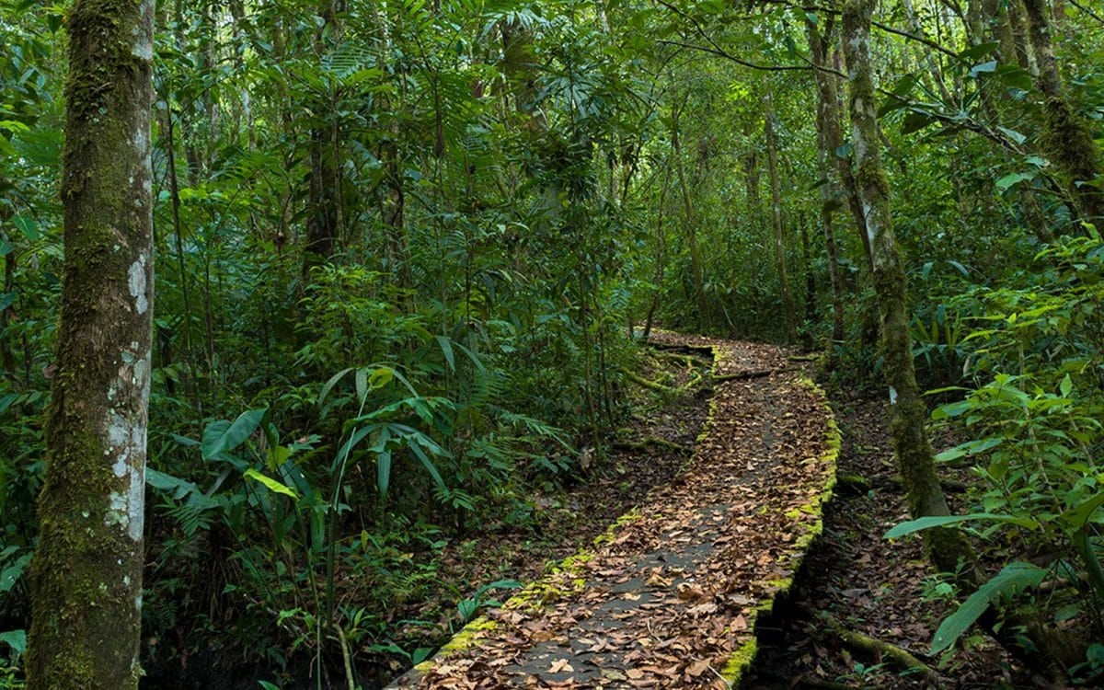

Lacondon jungle in Mexico

Howler monkey



El Yunque National Rainforest

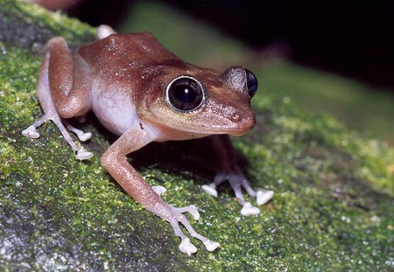 el coquí