Listening practice
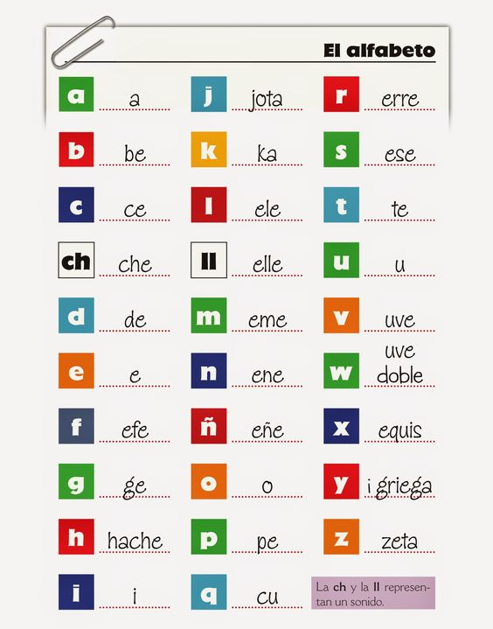

Write the letter you hear.
1 |  |  | 8 |  |  | 15 |  |  | 22
2 |  |  | 9 |  |  | 16 |  |  | 23
3 |  |  | 10 |  |  | 17 |  |  | 24
4 |  |  | 11 |  |  | 18 |  |  | 25
5 |  |  | 12 |  |  | 19 |  |  | 26
6 |  |  | 13 |  |  | 20 |  |  | 27
7 |  |  | 14 |  |  | 21 |  |  | 28

