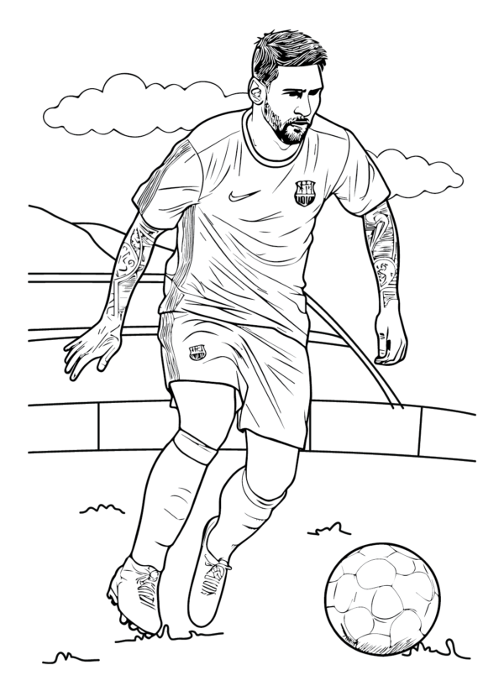
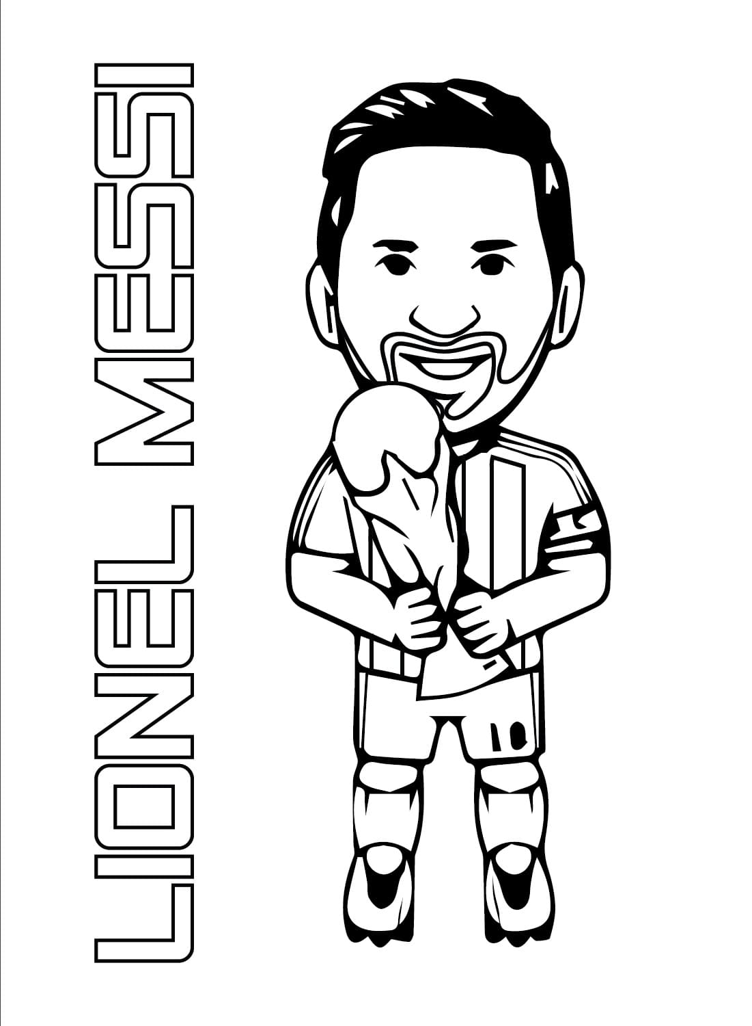
Image Info : ColoringLib presents to you Little Lionel Messi coloring page with JPG format, a resolution of 1101 × 1500 , and image size: 77 KB . You can download and print the printable Little Lionel Messi coloring image for free. You also can

