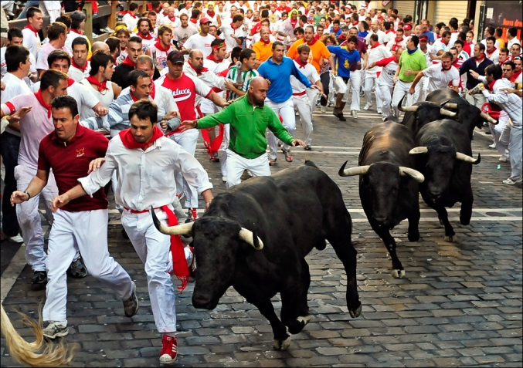

Running of the bulls in Pamplona, Spain

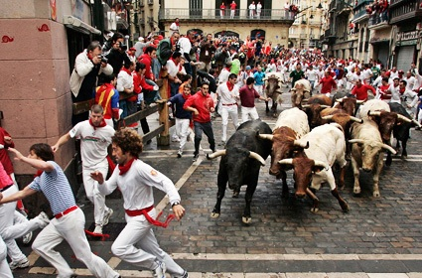

1992 Summer Olympics