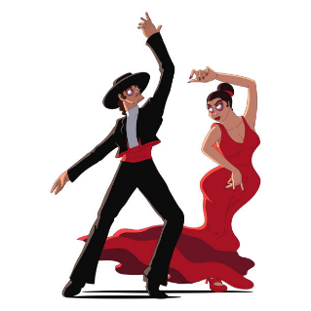

Nombre ______________________________________
El flamenco

What is Flamenco?

Flamenco is an ______________________ that contains three parts:

1)

2)

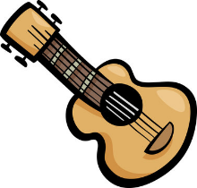
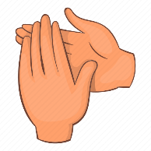
3)

Where did flamenco originate?
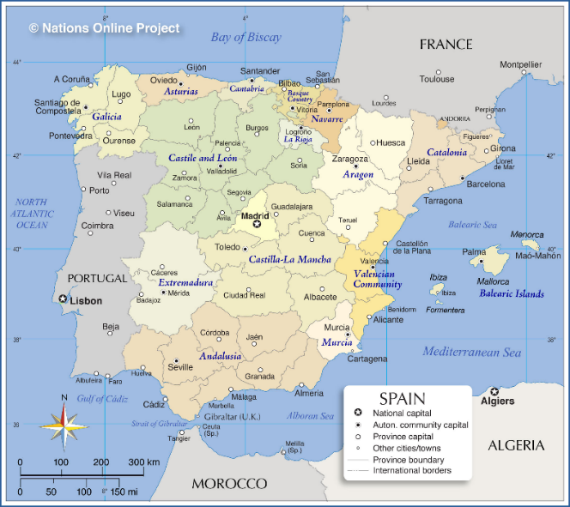

How are flamenco musicians and dancers trained?

1) Traditionally, flamenco artists learned their art from

_____________________________, _____________________________,

and _____________________________.

2) In modern times, flamenco artists are ____________________________.

3) However, people still participate casually in flamenco

__________________________________________________________ or

____________________________________________________________.

What do flamenco dancers wear?

Las mujeres (women):

1)

2)

3)

Los hombres (men):
1)

2)

3)

4)

What props might a female flamenco dancer use?

1)

2)

What are the basic elements of flamenco dance?

1)

2)

3)

4)

