Nombre __________________________________________

**Proyecto: El arte de Hercule Van Wolfwinkle**

For this assignment, write one sentence in Spanish to describe each of the animals in our Hercule Van Wolfwinkle slideshow.

* We do not know if each animal is a boy or a girl, so you will have to guess. (Hercule Van Wolfwinkle doesn’t know either, so he guesses too!) Please make *approximately* *half* of them boys (***él***) and *approximately half* of them girls (***ella***) for good sentence variety.
* If you decide that an animal is a girl (***ella***), consider whether you need to change the adjective to make it feminine. (Example: *Ella es pequeñ****a***.) Only the adjectives that end in “o” will have to change to “a.”
* For this project, please use at least **15 DIFFERENT adjectives**. Remember, colors count as adjectives too.
* Incorporate the words **muy** (*very*) and **un poco** (*a little*) in some of your sentences. (Example: *Ella es* ***muy*** *chistosa*.)
* Feel free to use the word “no” in your descriptions. Put the word “no” *before* *the verb*. (Example: *Él* ***no*** *es simpático*.)
* Write more than one adjective for some animals. Use the word **y** (*and*). (Example: *Él es grande* ***y*** *negro*.)

**Examples:**

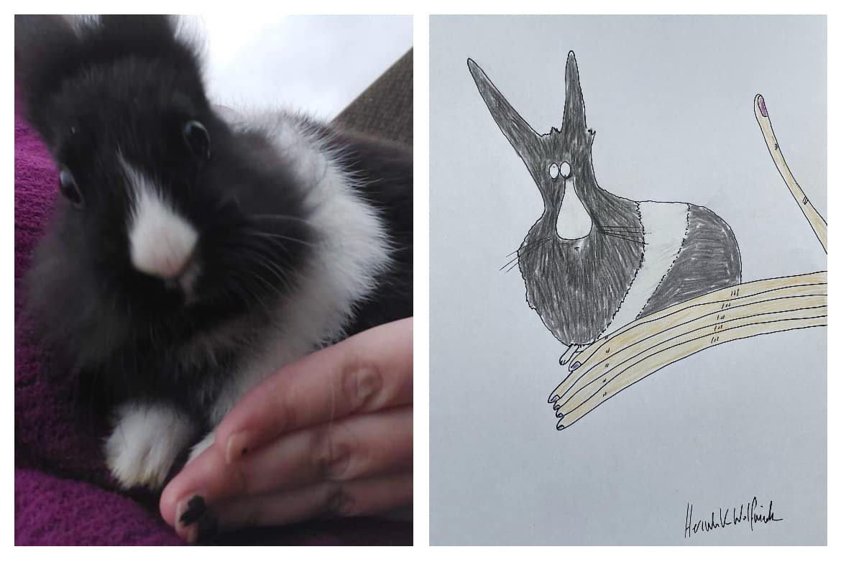

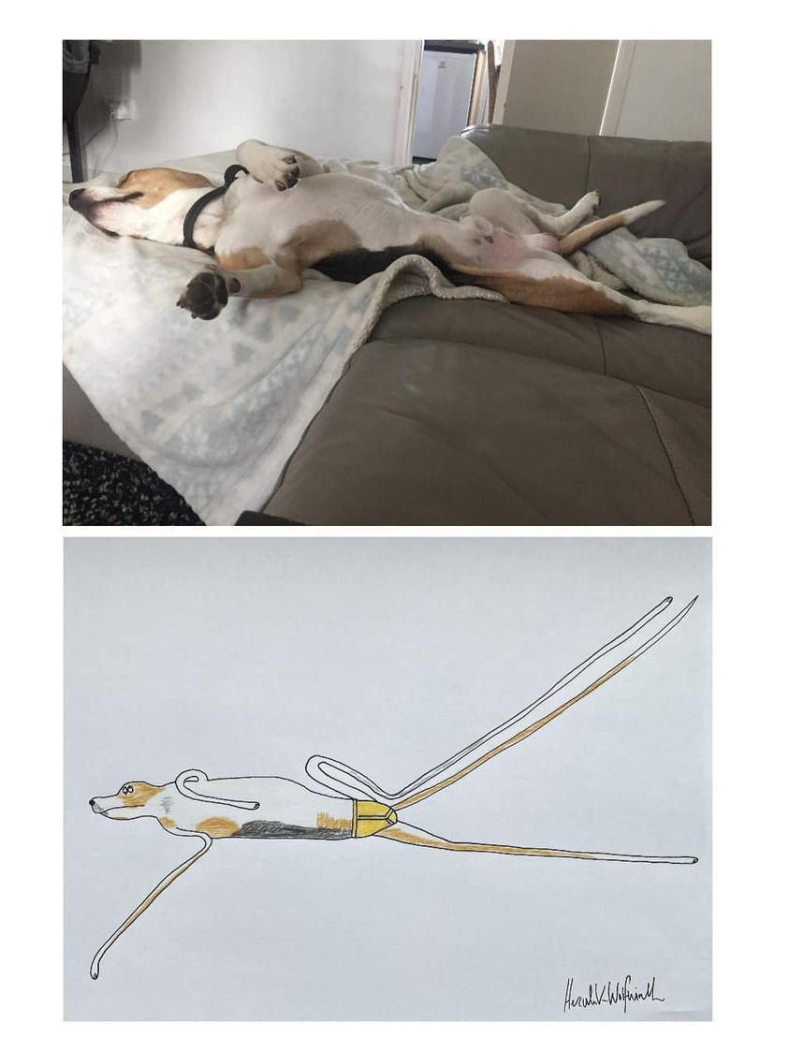Ella es blanca y negra.

Él es muy largo.

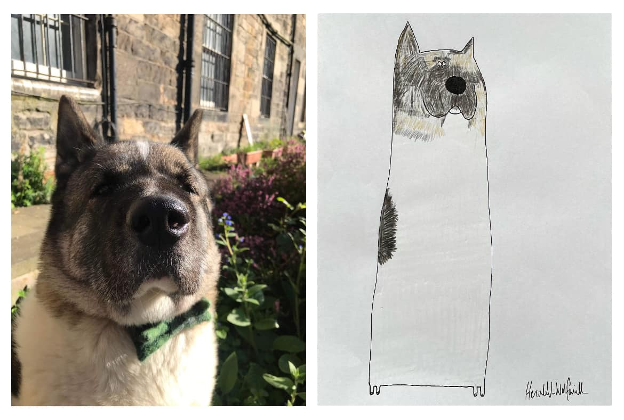

Él es grande y un poco antipático.

Nombre _________________________________________

El arte de Hercule Van Wolfwinkle

1. _________________________________________________________
2. _________________________________________________________
3. _________________________________________________________
4. _________________________________________________________
5. _________________________________________________________
6. _________________________________________________________
7. _________________________________________________________
8. _________________________________________________________
9. _________________________________________________________
10. _________________________________________________________
11. _________________________________________________________
12. _________________________________________________________
13. _________________________________________________________
14. _________________________________________________________
15. _________________________________________________________
16. _________________________________________________________
17. _________________________________________________________
18. _________________________________________________________
19. _________________________________________________________
20. A drawing of a bird in a frame

    Description automatically generatedA gold frame with a drawing of a cat

    Description automatically generated _________________________________________________________

