Week 5
Spanish Newsletter

morado - purple
dieciocho - 18
pierna(s) – leg(s)
los pies – feet
más o menos – okay
boca – mouth
nariz - nose
Word to encourage use at home:
Hola - Hello
Adiós - Goodbye

Common phrases used in class today, but not necessarily vocabulary words:
¿Cómo estás? – How are you?
¿Dónde están? -Where are they?
¿Cuál es tu color favorito? - What is your favorite color?

Review:
Numbers 1-17
Colors- rojo, verde, azul, amarillo
Body parts- las manos, los brazos, los dedos
Each day we end class with a goodbye song in Spanish. Encourage your children to sing this with you.
Saludos Song- Sing to the tune of “Mary Had a Little Lamb”
Adiós means goodbye-goodbye- goodbye
Adiós means goodbye
¡Adiós amigos! (clapping)



Notas Culturales/Class Activities
Today we looked at a globe and talked about Spanish speaking countries like Mexico, Puerto Rico, Guatemala, and Ecuador. People in many Spanish speaking countries love bright colors. In some countries like Mexico or Puerto Rico, for example, people paint their houses bright colors such as blue, pink, and yellow. Ask your child if they would like to live in a brightly colored house and if so, which color.
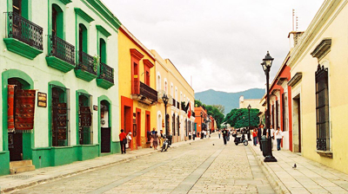

Preschool

Vocabulary List
We encourage you to practice vocabulary at home with your children. They will remember much more!
Tip: Play Simon Says with body parts in Spanish at home. Play I Spy to review colors in Spanish at home.

Information
Please contact the Futura Language Professionals Coordinator, coordinator@FuturaAdventures.com with any questions about Spanish class.
***This is our general preschool newsletter, please note that specific content per classroom may vary.

Futura Language Professionals
www.FuturaAdventures.com
Cantamos- Let’s Sing

