How to share your screen to all meeting breakout rooms:
1. Click Share Screen in the meeting controls.
2. Enable the Share to breakout rooms option along the bottom of the share window.
3. Choose what you would like to share, including an entire screen, a specific open program, or others.
4. (Optional) Click the Share Sound option as well to include audio with the shared content.
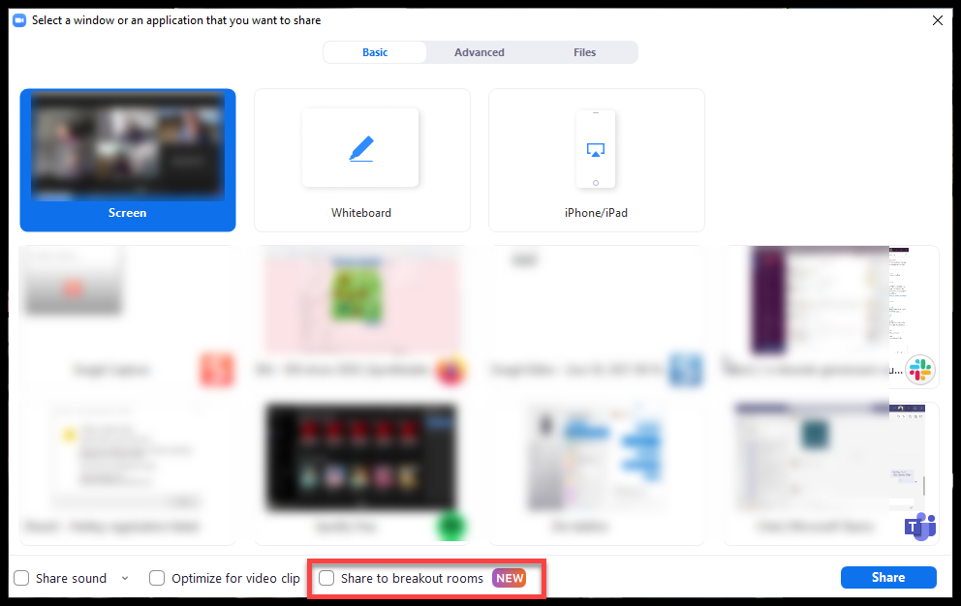
5. Click Share. The selected content will be shared to all breakout rooms. Any active shares in any breakout rooms will be interrupted for the host's/co-host's shared screen. Annotation or whiteboarding is saved before the host's shared content is viewed

