Nombre ________________________________________

**La hora 1**

Write the time in Spanish.

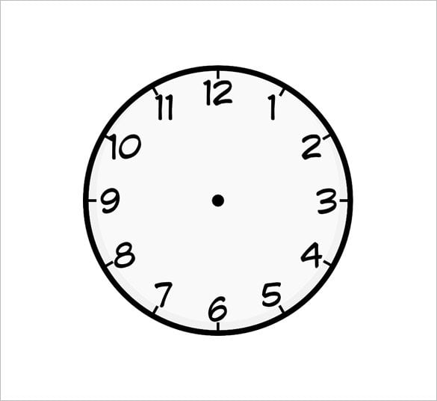

Ejemplo: **__*Son las cinco y veinte*___.**





1. ____________________________ 2. ________________________





3. ____________________________ 4. ________________________





5. ___________________________ 6. ____________________________



7. ____________________________ 8. ____________________________





9. ____________________________ 10. ___________________________