Nombre ______________________________________________

Mi viaje a La Ciudad de México
For this project, you will be planning a trip to La Ciudad de México (Mexico City)! You will be bringing one family member, friend, or pet. You will be using Google Slides to write your itinerary for your trip (completely en español!). You will be using the following information to write your intinerary:

- el vocabulary de los lugares de la comunidad
- actual sites in Mexico City
- el verbo IR (to go)
- ir + a + place (Ejemplos: Yo voy al museo. Nosotros vamos a la panadería.)
- ir + a + infinitive (Ejemplos: Yo voy a comer los tacos. Ella va a ver el arte.)
______________________________________________________________

Use the following guidelines to complete your project:

Slide #1:
Include the following:
- the title: Mi viaje a La Ciudad de México
- a picture of Mexico City
- a map showing where Mexico City is located
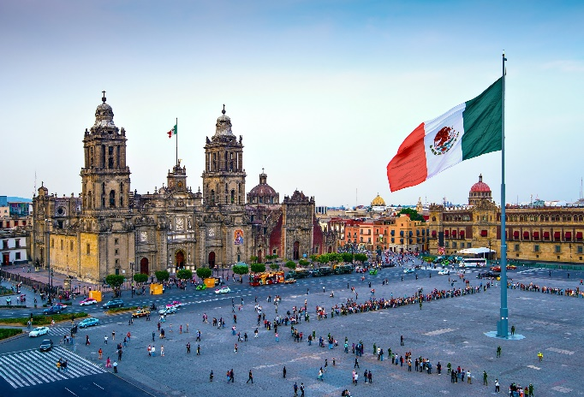
- your name

Slide #2:
ANSWER the following questions in Spanish:
¿Adónde vas? (Where are you going?)
¿Con quién vas? (With whom are you going?)
¿Cómo van Uds.? (How are you all getting there?)
Include some pictures or visuals to make this page more interesting.

Slides #3-10:
For EACH slide, write TWO sentences. You will be answering these questions on each slide:
¿Adónde vas? (Where are you going?) HINT: Use ir + a + place
¿Qué vas a hacer? (What are you going to do?) HINT: Use ir + a + infinitive

Assume that you and your travel companion do not always want to do the same things. Sometimes you do things together, and sometimes you will split up. Therefore, some of the slides will use the pronoun yo, some will use él or ella, and some will use nosotros or nosotras. Make sure you include a variety of pronouns throughout your project.

For Slides #3-10, you should include at least one picture of the place you are visiting.

YOUR PROJECT IS DUE ___________________________________________.

Transition Words and Helpful Vocabulary:
primero first con with
segundo second en in/by
luego then avión airplane
entonces then carro car
después after tren train
finalmente finally barco boat
en la mañana in the morning bicicleta bicycle
en la tarde in the afternoon
por la noche at night
el próximo día the next day

Los infinitivos:
bailar to dance leer to read
caminar to walk mirar to watch
comer to eat nadar to swim
comprar to buy probar to try; to sample
descansar to rest sacar fotos to take pictures
dormir to sleep subir to climb, go up
escuchar to listen tomar un café to drink coffee
explorar to explore ver to see
gastar dinero to spend money visitar to visit
hablar to talk

Note that some of these infinitive sentences will require additional vocabulary in order to make sense.

Example:
Yo voy a ver. I am going to see. (Going to see what??)
Yo voy a ver el arte. I am going to see the art.

