Nombre ________________________

**La comida**

Label the following food items in Spanish with your partner. Be sure to include the article (*el, la, los, las*).

|  |  |
| --- | --- |
| Premium Vector | Cartoon vector illustration isolated object delicious  flour food bakery bread whole grain toast1. | Free Download Eggs Animation Transparent Clipart Chicken - Animated Picture  Of Eggs - Free Transparent PNG Download - PNGkey2. |
| Salad Cartoon Images – Browse 95,455 Stock Photos, Vectors, and Video |  Adobe Stock3. | Corn Cob Cartoon Images – Browse 10,041 Stock Photos, Vectors, and Video |  Adobe Stock4. |
| Watermelon Clipart Images – Browse 14,192 Stock Photos, Vectors ... - Clip  Art Library5. | Fried Fish Png - Fried Fish Clip Art, Transparent Png , Transparent Png  Image - PNGitem6. |
| Cheese Cartoon Images – Browse 165,400 Stock Photos, Vectors, and Video |  Adobe Stock7. | Cartoon French Fries png images | PNGWing8. |

**Mi comida favorita**

Answer the following questions with a Spanish word. Include the article (*el, la, los, las*). Choose a word from your packet.

1. *A group of fruit on a white background

   Description automatically generated* **¿Cuál es tu fruta favorita?** *(What is your favorite* ***fruit****?)*

_________________________________________

1. 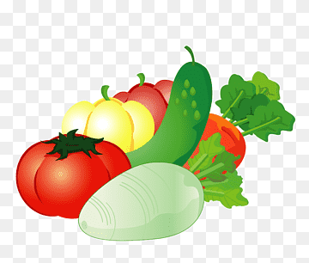**¿Cuál es tu verdura favorita?** *(What is your favorite* ***vegetable****?)*

____________________________________________

1. **¿Cuál es tu carne favorita?** *(What is your favorite type of* ***meat****? If you do not eat meat, answer “ninguna” or “none of them”!)*



________________________________________