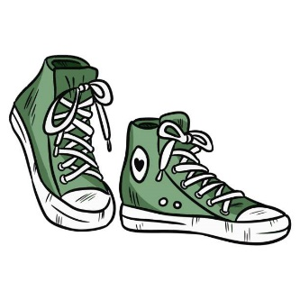Nombre _________________________________________

**Los adjetivos demostrativos y la ropa 1**

Write the correct demonstrative adjective and clothing word for each box. See the example.

|  |  |  |  |  |  |  |
| --- | --- | --- | --- | --- | --- | --- |
| **Ejemplo** | | **this shoe** | | **that shoe** | | **that (over there) shoe** |
|  | | este zapato | | ese zapato | | aquel zapato |
| 1. | | this dress | | that dress | | that (over there) dress |
|  | |  | |  | |  |
| 2. | | this ring | | that ring | | that (over there) ring |
|  | |  | |  | |  |
| 3. | | these scarves | | those scarves | | those (over there) scarves |
|  | |  | |  | |  |
| 4. | | these pants | | those pants | | those (over there) pants |
|  | |  | |  | |  |
| 5. | | this purse | | that purse | | that (over there) purse |
|  | |  | |  | |  |
| 6. | this suit | | that suit | | that (over there) suit | |
|  |  | |  | |  | |
| 7. | these gloves | | those gloves | | those (over there) gloves | |
|  |  | |  | |  | |
| 8. | these skirts | | those skirts | | those (over there) skirts | |
|  |  | |  | |  | |
| 9. | this necklace | | that necklace | | that (over there) necklace | |
|  |  | |  | |  | |
| 10. | this coat | | that coat | | that (over there) coat | |
|  |  | |  | |  | |

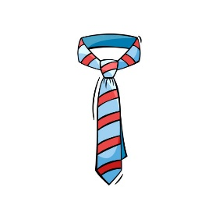Nombre _________________________________________

**Los adjetivos demostrativos y la ropa 2**

Write the correct demonstrative adjective and clothing word for each box. See the example.

|  |  |  |  |  |  |  |
| --- | --- | --- | --- | --- | --- | --- |
| **Ejemplo** | | **this tie** | | **that tie** | | **that (over there) tie** |
|  | | esta corbata | | esa corbata | | aquella corbata |
| 1. | | this cap/hat | | that cap/hat | | that (over there) cap/hat |
|  | |  | |  | |  |
| 2. | | this sweater | | that sweater | | that (over there) sweater |
|  | |  | |  | |  |
| 3. | | these shirts | | those shirts | | those (over there) shirts |
|  | |  | |  | |  |
| 4. | | these earrings (small) | | those earrings (small) | | those (over there) earrings (small) |
|  | |  | |  | |  |
| 5. | | this blouse | | that blouse | | that (over there) blouse |
|  | |  | |  | |  |
| 6. | this coat | | that coat | | that (over there) coat | |
|  |  | |  | |  | |
| 7. | these T-shirts | | those T-shirts | | those (over there) T-shirts | |
|  |  | |  | |  | |
| 8. | these sweatshirts | | those sweatshirts | | those (over there) sweatshirts | |
|  |  | |  | |  | |
| 9. | this bracelet | | that bracelet | | that (over there) bracelet | |
|  |  | |  | |  | |
| 10. | this swimsuit | | that swimsuit | | that (over there) swimsuit | |
|  |  | |  | |  | |

Nombre ______________________________________

Nombre ___________________________________________

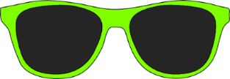**Los adjetivos demostrativos y la ropa 3**

**Parte A:** Complete the grid with the correct demonstrative adjective.

**THIS/THESE:**

Singular: Plural:

|  |  |  |  |  |
| --- | --- | --- | --- | --- |
| masculine: |  | this |  | these |
| feminine: |  | this |  | these |

**THAT/THOSE (near):**

Singular: Plural:

|  |  |  |  |  |
| --- | --- | --- | --- | --- |
| masculine: |  | that (near) |  | those (near) |
| feminine: |  | that (near) |  | those (near) |

**THAT/THOSE (far; way over there):**

Singular: Plural:

|  |  |  |  |  |
| --- | --- | --- | --- | --- |
| masculine: |  | that (far) |  | those (far) |
| feminine: |  | that (far) |  | those (far) |

**Parte B:** Write the saying that helps you remember the demonstrative adjectives.

______________________________________________________________

______________________________________________________________

**Parte C:** Write the correct demonstrative adjective and clothing word in Spanish.

1. this sweatshirt _________________________________________
2. that suit _____________________________________________
3. these necklaces ________________________________________
4. that (over there) jacket __________________________________
5. these scarves __________________________________________
6. that skirt ______________________________________________
7. those T-shirts __________________________________________
8. those (over there) dresses

____________________________________________________

1. this swimsuit _________________________________________
2. 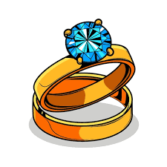 that (over there) ring ____________________________________