SEMANA (week) | FECHA (date)
Semana 6

1. Food and Dining Review. Click here to practice online with flashcards and interactive games on Quizlet La comida: food vocabulary

Planeando salir a comer – Planning dining out

1. Vamos a comer ________. Let’s go eat breakfast, lunch OR dinner
2. Si, vamos. ¡Tengo hambre! Yes, let’s go. I am hungry!
1. Te gusta el restaurante_________. Do you like the restaurant_______.
2. Si, me gusta ____ OR No, no me gusta_____. Yes, I like it. OR No, I don’t like it.

En el restaurante - At the restaurant
1. ¿Qué le gustaría comer? What would you like to eat?
2. Me gustaría _______ y ________. I would like_________ and _______.
1. ¿Cuánto cuesta______? OR ¿Cuánto cuestan______? How much does it cost? How much do they cost?
2. Cuesta $____dólar/dólares It cost____dollars.

Comiendo- Eating
1. Mmm… ¡Qué rico! Mmm… How delicious!
2. Si. ¡Buen provecho! Yes. Enjoy your meal!

Hora de pagar - Time to pay
1. Disculpe. La cuenta, por favor. Excuse me. The check, please.
2. Aquí tiene. Pago solo en efectivo. Here you go. Pay in cash only.
1. ¿Cuánto es? How much is is?
2. Es ____ dólares y ____ centavos. It is ____dollars and ___ cents.
1. Gracias. Thank you.

2. La Gramática – Grammar:
¿El o la? Gender of Spanish Nouns
- Gender can be determined by word meaning. The word for “man” will be masculine; for “woman” will be femenine: El hombre/la mujer. Some words that are otherwise very similar will change the article and sometimes shift slightly in spelling to reflect gender: el estudiante/la estudiante, el profesor/la profesora.

- Languages, rivers, oceans, days of the week and months of the year are masculine

- Often, words ending in d, ión, z and a are feminine. These are sometimes referred to as “DIONZA” (d-ión-z-a) words to help you remember which endings are often (but not always!) feminine. So, DIONZA, (d-ión-z-a) endings are feminine.

- Often (but not always!), words ending in “LONER” (l,o,n,e,r) are masculine. These may be referred to as “loner” words to help you remember the key endings.
So, LONER (l-o-n-e-r) endings are maculine.
- Remember that definite & indefinite articles (el , la, los las, un, uno, unas, unos, etc) also singular or plural have to match the noun in masculine or feminine. Ej. La casa, las casas, el parque, los parques, etc.

Write down here some examples. Use the vocabulary words learned in prior classes (places, food, clothing, etc.)
FEMININE | MASCULINE
D-  I-  O-  N-  Z-  A- | L-  O-  N-  E-  R-

3. Verbs Review: ESTAR, SER, TENER, GUSTAR.
Click here to practice online with flashcards and interactive games on Quizlet. ESTAR -TO BE
Verbo ESTAR – to be
Person | Singular
1rst | I am | Yo estoy
2nd | you are informal | tú estás
3rth | he/she / you formal /it is | él/ella/ usted/ésto está
 | plural
1rst | we are | nosotros estamos
2nd | you (all) formal are  you (all) informal are | ustedes están  vosotros estáis
3rth | they are (all boys or mixed)  they are (all girls) | ellos están  ellas están

Examples:
- Yo estoy en la biblioteca. I am in the library.
- ¿Dónde está? Where is it?
- ¿Cómo está el clima? What is the weather like today?
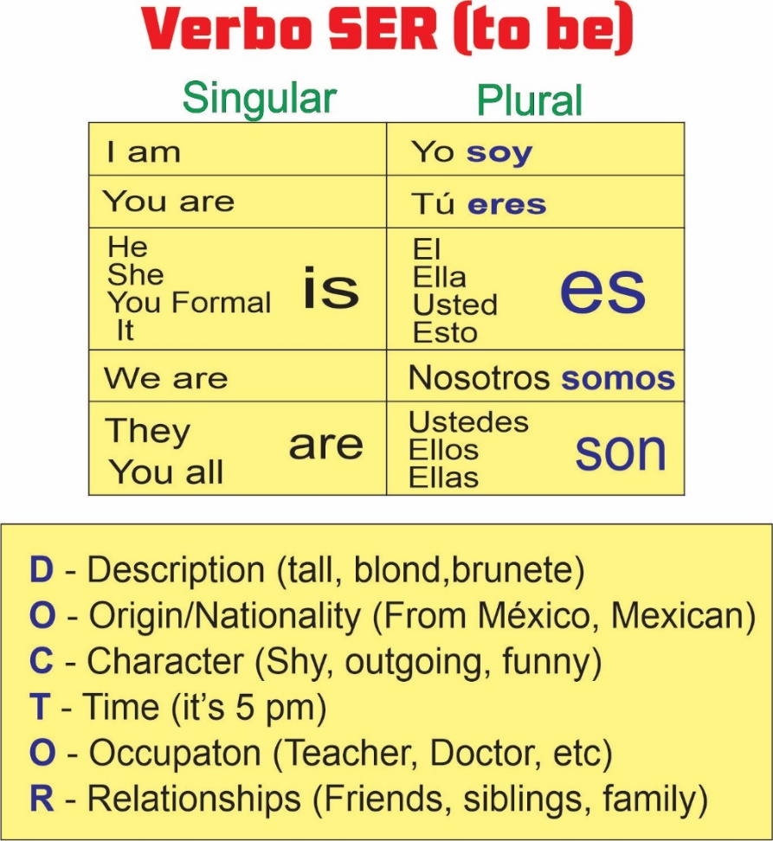
Click here to practice online with flashcards and interactive games on Quizlet. The Verb SER -TO BE

Examples:
- Somos altos. We are tall.
- Ellos son de México. They are from Mexico.
- Ella es muy tímida. She is very shy.
- Son las dos y media. It is 2:30.
- Tú eres ingeniero. You are an engineer.
- Él es mi hermano. He is my brother.

The Verb TENER: Click here to practice online with flashcards and interactive games on Quizlet TENER -to have

Verbo TENER – to have
Singular Plural
yo | tengo | nosotros  nosotras | tenemos
tú | tienes | ustedes | tienen
él, ella  usted | tiene | ellos  ellas | tienen

Examples:
- Yo tengo un carro. I have a car.
- Tú tienes una casa. You have a house.

Verbo GUSTAR – to like /to please. Click here to review the conjugations of the verb GUSTAR. Video ME GUSTA
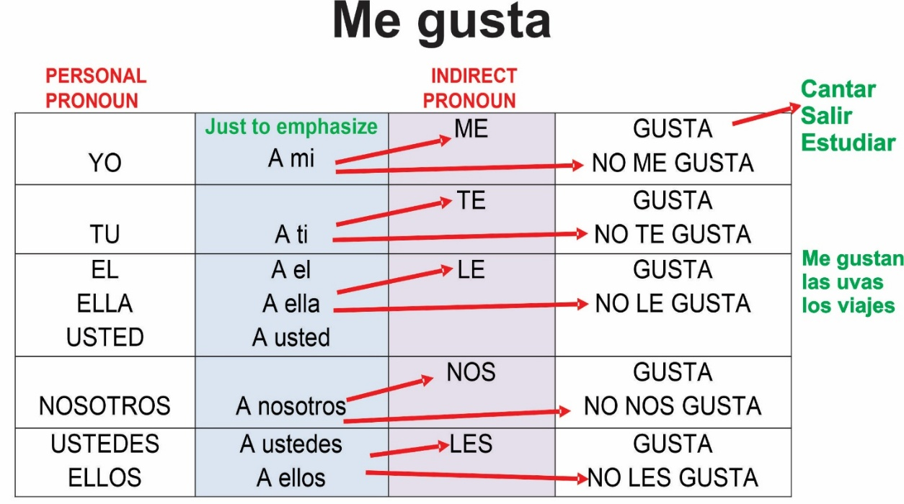

Examples:
- Me gusta el pollo. I like chicken.
- A ellos les gusta el pescado. They like the fish.
Conversación / Conversation Practice: The goal of this review practice is to incorporate the verbs learned: Ser, Estar, Tener, and Gustar in a conversation setting.
- ¿Qué te gusta hacer? What do you like to do?
- ¿Cómo eres? How would you describe yourself?
- ¿Cómo estás? How are you feeling?
- ¿Tienes hermanos? Do you have siblings?
- ¿Qué te gusta más? What do you like better?
- ¿Te gusta tu trabajo? Do you like your job/work?
- ¿Tienes mascotas? Do you have pets?
- ¿Cómo es tu mascota? How would you describe your pet?
- ¿Cómo está el clima hoy? What is the weather like today?
- ¿Cuántos años tienes? How old are you?
- ¿De dónde eres? Where are you from?

