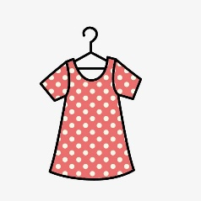Nombre _______________________________

El desfile de moda (Fashion Show)

**Step 1:** Choose ONE outfit to model in our fashion show!

Your outfit can be silly or fancy or funny. Be sure to select some interesting accessories. **You must be able to put your outfit on *over* your regular clothes OR pin your outfit to the front of your clothes using clothespins.** (We will not be able to go to the bathroom to change.) Ask a parent to help you select some good items to wear. Bring these items to school in a bag clearly marked with your name.



**Step 2:** Write a paragraph in Spanish describing your outfit.

Use the clothing vocabulary from your packet and the fashion show vocabulary (on the back of this page) to write a description of your outfit. **This paragraph will be collected for a grade.**

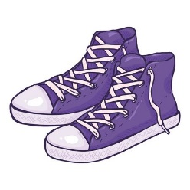**Step 3:** Choose a partner. (We can also have groups of three.)

Your partner will read your paragraph while you are walking down the runway. Make sure you write **neatly** so your partner can easily read your paragraph.

**Step 4:** Practice! Practice! Practice!

Practice reading your partner’s Spanish description of his/her outfit. Use a good announcer voice. Ask Señora Fiedler for any help with pronunciation. Practice walking down an imaginary runway. Remember, *fashion models have some attitude!*

**Step 5:** Perform!

We will perform our fashion show together as a class, complete with fashion show background music. Your classroom teacher(s) and Mr. Oberdorf will be our audience.

**Fashion Show Vocabulary**

**¡Mira esto!** *Look at this! (Check this out!)*

**¡Qué maravilla!** *How marvelous/wonderful!*

**¡Qué sofisticado!** *How sophisticated! (for a boy)*

**¡Qué sofisticada!** *How sophisticated! (for a girl)*

**¡Qué elegante!** *How elegant!*

**¡Qué sorprendente!** *How surprising!*

**¡Impresionante!** *Impressive!/Awesome!*

**él** *he* Remember, you can use your **color** words too!

**ella** *she* In Spanish, we put the color AFTER the noun. So,

**lleva** *is wearing the green shirt = la camisa verde*

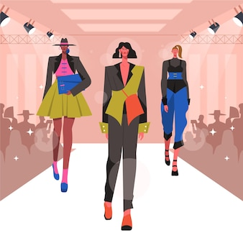**tiene** *has*

**con** *with*

**y** *and*

**también** *also*

**gracias**  *thank you*

**Sample Paragraph:**

¡Mira esto! María lleva el vestido rojo con la bolsa azul. Ella tiene el collar y la pulsera también. ¡Qué elegante! Y ella lleva el suéter verde con el sombrero grande. ¡Impresionante! ¡Gracias, María!

*Check this out! María is wearing a red dress with a blue purse. She has a necklace and a bracelet too. How elegant! And she is wearing a green sweater with a big hat! Impressive! Thank you, María!*

**Nombre ________________________________________**

Write a paragraph in Spanish that your announcer will read to describe your outfit for the fashion show. Your paragraph should include the following:

* 3 fashion show exclamations (Ex: *¡Qué maravilla!*)
* 5 clothing vocabulary words (from p. 6 of your Nivel Dos packet)
* 3 color words (from p. 2 of your Nivel Dos packet)
* *At least* 6 sentences total (The exclamations count as sentences. But be sure to also include a few sentences using *lleva* or *tiene*. See the sample paragraph.)

Write **NEATLY** so your announcer (partner) can read your writing!

______________________________________________________________

______________________________________________________________

______________________________________________________________

______________________________________________________________

______________________________________________________________

______________________________________________________________

______________________________________________________________

______________________________________________________________