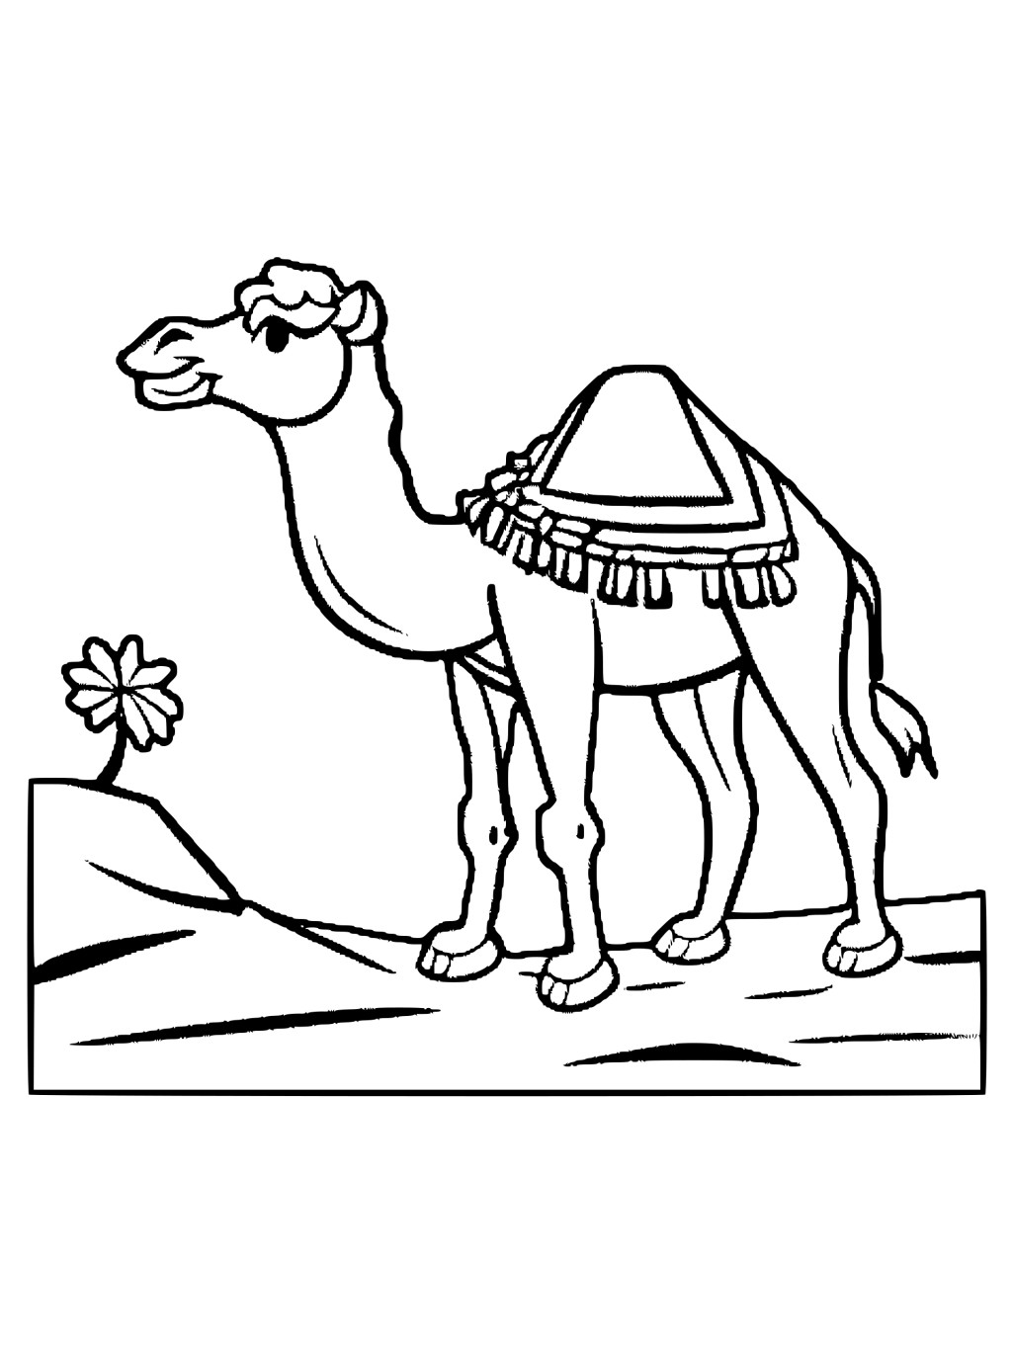

Nombre____________________

**Culture Resource Page: El Día de los Reyes Magos ~ Three Kings Day**

|  |  |  |  |
| --- | --- | --- | --- |
| **Los Reyes Magos** | The Three Wise Men | **el incienso** | the incense |
| **el camello** | the camel | **la estrella de Belén** | The star of Bethlehem |
| **el viaje** | the trip | **Jesús** | Jesus |
| **la corona** | the crown | **la rosca de reyes** | the King’s Cake |
| **el oro** | the gold | **el muñequito** | the small baby toy |

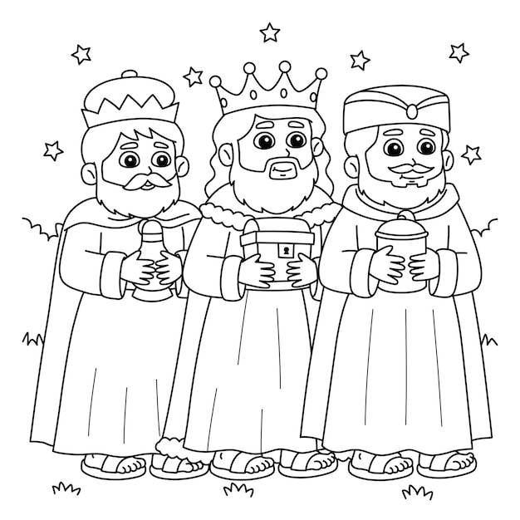

***Notas Culturales~* Culture Notes**

*El día de los Reyes Magos* is the holiday of Three Kings Day on January 6th. This holiday is celebrated by Latinos all over the world, particularly in Spain and Latin America, as a part of the Christmas story. Children leave their shoes out to be filled by the wise men when they visit on the night of the 5th (like stockings for Christmas). In current times, the Kings can place their gifts under the Christmas tree like Santa Claus does. *La Rosca de Reyes* is a popular treat eaten on January 6th during the celebration. The tradition is to hide a small *muñequito* (baby toy) inside the cake to symbolize baby Jesus. In Spain, whoever finds the baby is “king for the day”.