Nombre_______________________

**Culture Resource Page: Las Posadas ~ The Inns**

|  |  |  |  |
| --- | --- | --- | --- |
| **Las Posadas** | The Inns | **la flor de nochebuena** | the poinsettia |
| **la escena de Navidad** | the Nativity scene | **la fiesta** | the party |
| **José y María** | Joseph and Mary | **los tamales** | the tamales |
| **el burro** | the donkey | **el ponche de frutas** | the fruit punch |
| **el pesebre** | the manger | **el chocolate caliente** | the hot chocolate /  the hot cocoa |
| **la estrella** | the star | **los buñuelos** | the fritters |
| **el ángel** | the angel | **el pastel de frutas** | the fruit cake |
| **la vela** | the candle | **la piñata** | the piñata |
| **los villancicos** | the carols | **los dulces** | the candies |

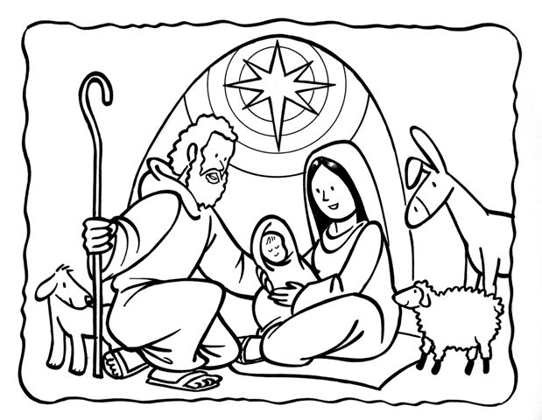

*Las Posadas~* The Inns

*Las Posadas* is an important party that is celebrated in some countries around Christmas time. *Posada* means shelter or inn. *Las Posadas* commemorates the journey that Joseph and Mary made looking for “posada” where Mary could give birth to the baby Jesus. Every December from the 16th to the 24th a party is held at someone’s house in the neighborhood. Everyone sings songs and carry candles while reenacting the original events. During the *fiesta* there are drinks, food, candy, and fruit. Every *posada* ends with the breaking of a *piñata* and when it breaks children run happily to gather its contents- *dulces* (candy), *juguetes* (toys), and *dinero* (money).