Nombre_______________________

**Culture Resource Page: Las Posadas ~ The Inns**

|  |  |  |  |
| --- | --- | --- | --- |
| **posadas** | inns | **flor de nochebuena** | poinsettia |
| **Nacimiento** | Nativity scene | **fiesta** | party |
| **José y María** | Joseph and Mary | **tamales** | tamales |
| **burro** | donkey | **ponche de frutas** | fruit punch |
| **pesebre** | manger | **chocolate caliente** | hot chocolate /hot cocoa |
| **estrella** | star | **dulces** | candy |
| **ángel** | angel | **pastel de frutas** | fruit cake |
| **vela** | candle | **piñata** | piñata |

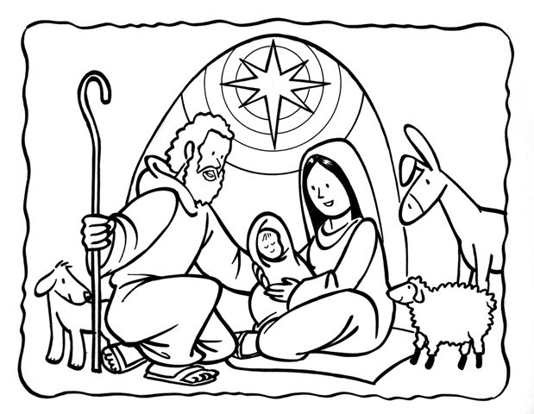

*Las Posadas~* The Inns

*Las Posadas* is an important party that is celebrated in some countries around Christmas time. *Posada* means shelter or inn. *Las Posadas* commemorates the journey that Joseph and Mary made looking for “posada” where Mary could give birth to the baby Jesus. Every December from the 16th to the 24th a party is held at someone’s house in the neighborhood. Everyone sings songs and carry candles while reenacting the original events. During the *fiesta* there are drinks, food, candy, and fruit. Every *posada* ends with the breaking of a *piñata* and when it breaks children run happily to gather its contents- *dulces* (candy), *juguetes* (toys), and *dinero* (money).