**Mi familia**

For this assignment you will….

* Make drawing of 10 family members
  + These family members CAN include pets.
  + These family members do NOT need to all live in your house.
* Label each family member with the following:
  + Their name
  + A Spanish word to describe their relationship to you
  + The English meaning in parenthesis

**Example: Katie**

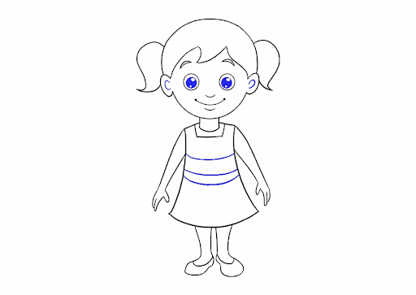**la hermana (sister)**

______________________________________________________________

**Grading**

You will be graded according to the following criteria:

* All items from checklist included (at least 10 family members, labeled correctly with name, Spanish word, and English translation)
* Neatness – I am not grading on artistic ability, but your drawing and handwriting should be neat and show effort.
* Spelling – Please use your packet to spell your Spanish words correctly

**Mi familia project – Grading Checklist**

* 10 family members, each labeled with:
  + Person’s name
  + Spanish word describing relationship
  + English translation
* Neatness and Effort
  + Drawings are neat
  + Handwriting is clear and easy to read
* Spanish words spelled correctly

**Grade: _______**

**Mi familia project – Grading Checklist**

* 10 family members, each labeled with:
  + Person’s name
  + Spanish word describing relationship
  + English translation
* Neatness and Effort
  + Drawings are neat
  + Handwriting is clear and easy to read
* Spanish words spelled correctly

**Grade: _______**

**Mi familia project – Grading Checklist**

* 10 family members, each labeled with:
  + Person’s name
  + Spanish word describing relationship
  + English translation
* Neatness and Effort
  + Drawings are neat
  + Handwriting is clear and easy to read
* Spanish words spelled correctly

**Grade: ______**