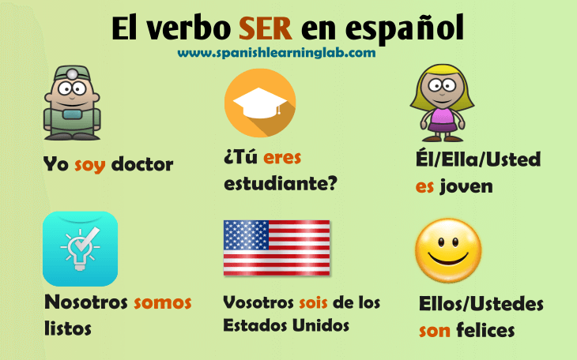**ser = to be**

**estar = to be**

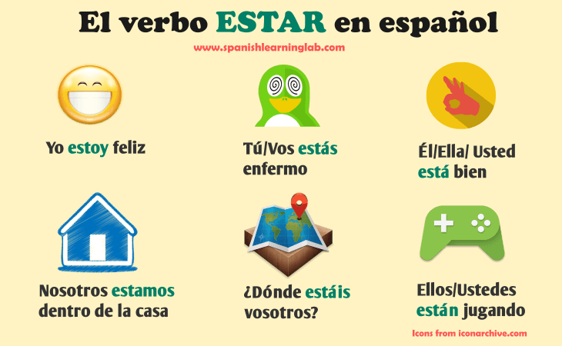

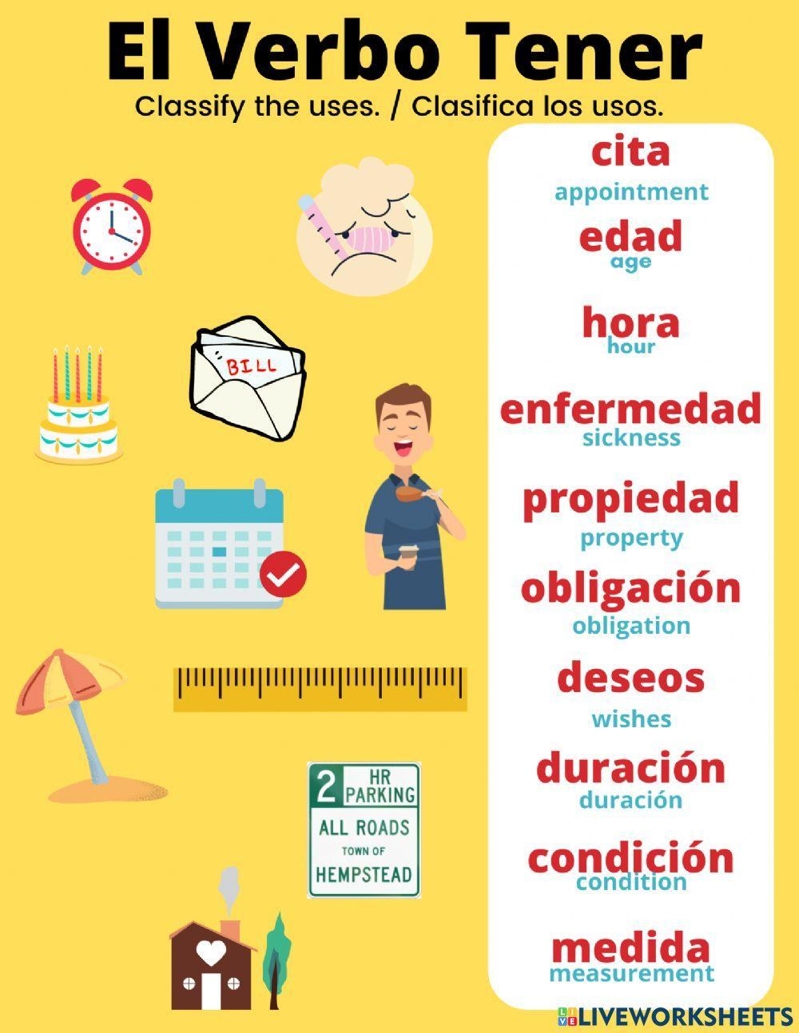

**tener = to have**

**gustar = to like**

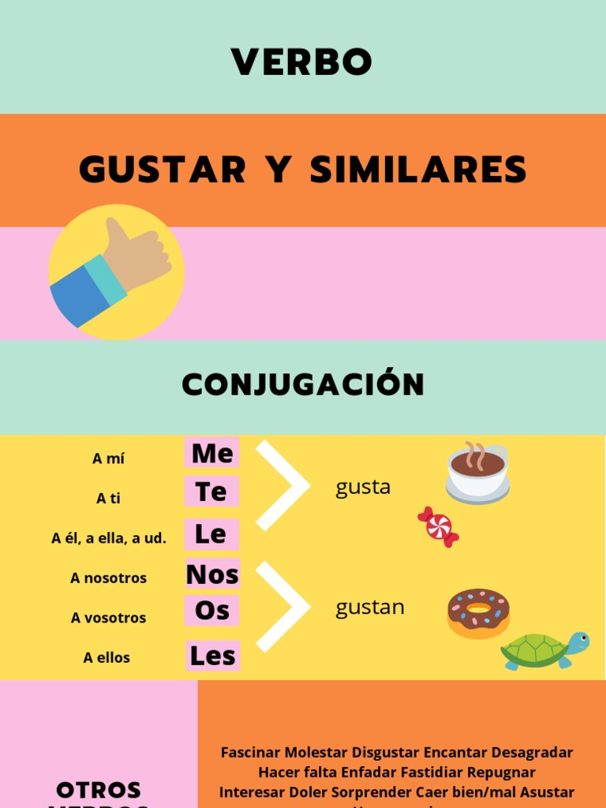

**yo**



**tú**

**él**

**ella**

**usted**



**nosotros/as**

**vosotros/as**

**ellos**

**ellas**

**ustedes**