**You are invited!**

**What:** ¡El zoológico español! (The Spanish Zoo!)

**When:** Thursday, June 2. Walk through any time between 10:30-11:05.

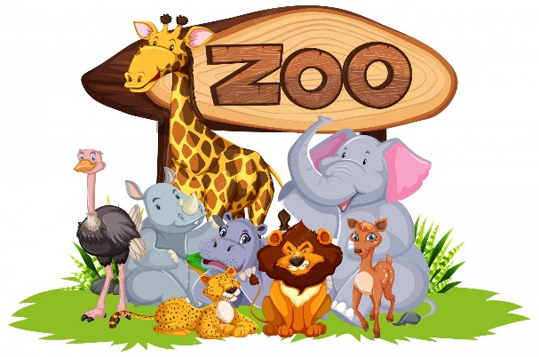**Who:** Hosted by Grades 3 and 4

**Where:** The SJE Library

**Why:** Zoo staff will *only* be speaking Spanish during zoo hours! Come and learn Spanish vocabulary for animals, colors, body parts, and weather conditions!

**You are invited!**

**What:** ¡El zoológico español! (The Spanish Zoo!)

**When:** Thursday, June 2. Walk through any time between 10:30-11:05.

**Who:** Hosted by Grades 3 and 4

**Where:** The SJE Library

**Why:** Zoo staff will *only* be speaking Spanish during zoo hours! Come and learn Spanish vocabulary for animals, colors, body parts, and weather conditions!

El zoológico español



**Grade:** ________

**Date:** Thursday, June 2

**Location:** SJE Library

**Approximate arrival time:** ________

**¡Bienvenidos al zoológico español!**

Welcome to the Spanish Zoo!

Please review the following guidelines before your visit:

1. Do not touch or feed the zoo animals.
2. Stay in a line and follow the flow of traffic. Our Manager/Guest Services director will assist your group if you do not know where to go.

1. The Zoo Staff will *only* be speaking Spanish during zoo hours. They will greet you and point out the animals, colors, animal body parts, and animals’ preferred weather conditions.
2. Customers are encouraged to use their Spanish to speak to zoo staff about the animals!