

**Cinco de Mayo**

By studying Cinco de Mayo, a Mexican holiday, students gain an understanding of the meaning of the celebration.

## **Objectives:**

* Students will understand what happened at the Battle of Puebla
* Students will understand why this holiday is celebrated today

**Materials**: copies of the Cinco de Mayo information sheet, board space or chart paper to brainstorm with class during the lesson, color photos from the Internet to show the class regarding the holiday (optional), craft supplies (optional)

Notes: This lesson duration is one class period. Feel free alter as needed and incorporate one of the craft ideas included. Also, this holiday could include a class fiesta to celebrate Mexican culture.

**Procedure:**

* 1. Begin by asking students what they know about Cinco de Mayo. Typical answers may include the meaning of the name (fifth of May), as well as the common belief that it is Mexico’s Independence Day. Address these items if they do not arise in the conversation.
  2. Distribute the Cinco de Mayo information sheet and choose to either read it aloud, have students read in pairs or read silently.
  3. After they are complete, pair up students to work on the discussion questions included in this lesson.
  4. Circle around the room and help if needed.
  5. After most are complete, discuss the answers orally asking for volunteers.
  6. Main points to stress in this discussion:
     1. May 5 is NOT Mexico’s Independence Day.
     2. This holiday is only popular in the Puebla region of Mexico.
     3. Many Americans celebrate Cinco de Mayo by enjoying Mexican culture, though the majority do not know the history behind the holiday.
  7. If time, preview and share pictures and video clips on YouTube regarding this holiday.
  8. Choose one of the Cinco de Mayo crafts or activities to include after the discussion if desired.

**Extensions:** Encourage students to conduct more research on the Battle of Puebla and bring their findings back to class to share.

Research popular Mexican dishes like horchata, tamales, etc. and take volunteers to make them and bring them in for a Cinco de Mayo fiesta.



**Cinco de Mayo**

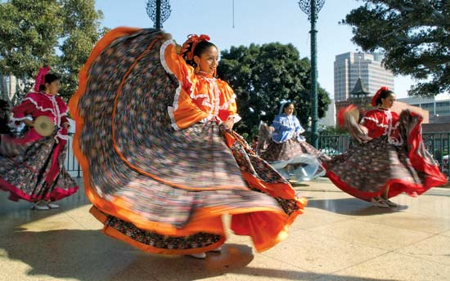**Cinco de Mayo,**( “Fifth of May”) , also known as the **Anniversary of the Battle of Puebla**, is a [holiday](https://www.britannica.com/topic/holiday) celebrated in parts of [Mexico](https://www.britannica.com/place/Mexico) and the [United States](https://www.britannica.com/place/United-States) in honor of a military victory in 1862 over the French forces of [Napoleon III](https://www.britannica.com/biography/Napoleon-III-emperor-of-France).

The French, with the support of wealthy landowners, attempted takeover Mexico. On May 5, 1862, the French invaded the town of Puebla with their well-training soldiers and extensive weapons. Meanwhile, the poorly equipped [mestizo](https://www.britannica.com/topic/mestizo) and [Zapotec](https://www.britannica.com/topic/Zapotec) people of Puebla, under the command of General Ignacio Zaragoza tried their best to defend their land and defeated French troops at the [Battle of Puebla](https://www.britannica.com/event/Battle-of-Puebla). About 1,000 French troops were killed. Although the fighting continued and the French were not driven out for another five years, the victory at [Puebla](https://www.britannica.com/place/Puebla-Mexico) became a symbol of Mexican resistance to foreign domination. The city, which was later renamed Puebla de Zaragoza, is the site of a museum devoted to the battle, and the battlefield itself is maintained as a park.

The day is celebrated in the state of [Puebla](https://www.britannica.com/place/Puebla-state-Mexico) with parades, speeches, and reenactments of the [1862 battle](https://www.britannica.com/event/Battle-of-Puebla), though it is not much noticed in most of the rest of the country.

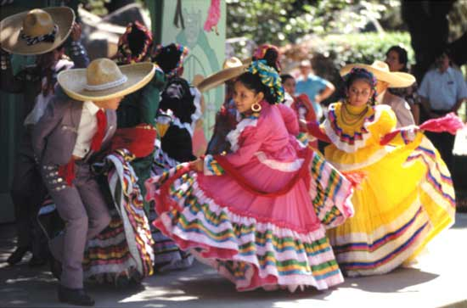

In the mid-20th-century U.S., the celebration of Cinco de Mayo became among Mexican immigrants a way of encouraging pride in their Mexican heritage. Nowadays, the holiday is even more popular in the United States as it is in most regions in Mexico. Americans enjoy celebrating Mexican culture on this day, though many believe it is Mexico’s Independence Day, which actually falls on September 16.



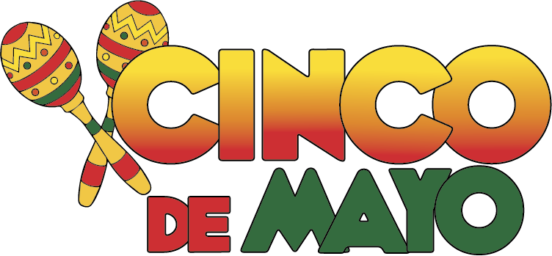**Cinco de Mayo: Questions Nombre:_______________________________**

1. When is ‘Cinco de Mayo’ and what does it celebrate?
2. Why was this battle such a big deal?
3. What was the role of Napoleon III?
4. Who led the Mexican side of the battle?
5. Is this holiday celebrated in all of Mexico?
6. Why is the holiday popular in the United States?
7. What do most Americans think about ‘Cinco de Mayo’?
8. When is the Mexican Independence day?
9. Have you ever celebrated this holiday? How?



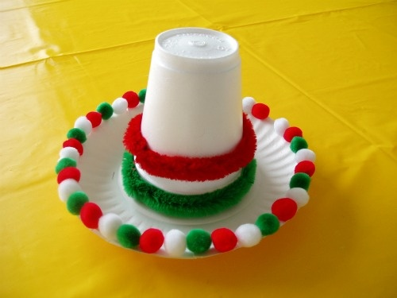**Cinco de Mayo Craft Ideas:**

**Mini Sombreros:**

**Materials:** styrofoam cups, small paper plates, glue, miniature pom-poms, pipe cleaners

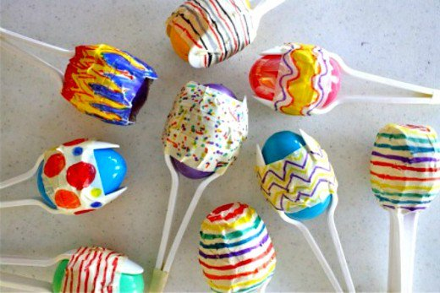

**Maracas:**

**Materials:** plastic eggs, plastic spoons, masking tape, permanent markers, dry beans

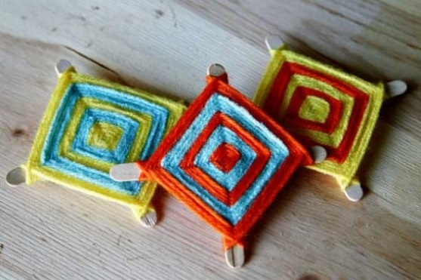**Ojo de Dios:**

**Materials:** colored yarn, popsicle sticks

http://www.wikihow.com/Make-God%27s-Eye

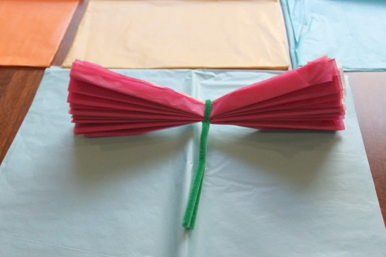(Follow the link, search “god’s eye tutorial” for detailed instructions)

**Tissue Paper Flowers:**

**Materials**: colored tissue paper cut in squares, pipe cleaners

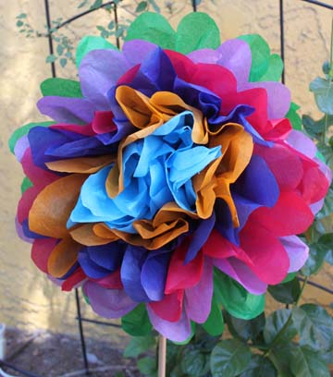<http://www.instructables.com/id/Tissue->

Paper-Flowers/

(or search “tissue paper flower tutorial” for detailed instructions)