**Culture Resource Page: Felices Pascuas**

|  |  |  |  |
| --- | --- | --- | --- |
| **Felices Pascuas (Pascua)** | Happy Easter  (Easter) | **cordero** | lamb |
| **conejo** | bunny | **pollito** | chick |
| **canasta /cesta** | basket | **chocolate** | chocolate |
| **huevos** | eggs | **dulces** | candy |

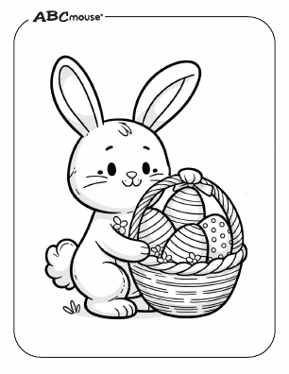

*La Semana Santa~* The Holy Week of Easter

The Holy Week of Easter known as la Semana Santa, is the most important Catholic festival in South America. La Semana Santa is observed with a range of celebrations, from very religious to commercial.