Culture Resource Page: Felices Pascuas

Felices Pascuas  (La Pascua) | Happy Easter  (Easter) | el cordero | the lamb
El conejo de Pascua | The Easter bunny | el pollito | the chick
la canasta /la cesta | the basket | el chocolate | the chocolate
los huevos de Pascua | the Easter eggs | los dulces | the candy

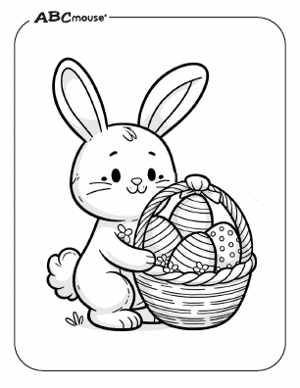
La Semana Santa~ The Holy Week of Easter

The Holy Week of Easter known as la Semana Santa, is the most important Catholic festival in South America. La Semana Santa is observed with a range of celebrations, from very religious to commercial.

