1. Ice Breakers & Get to know each other conversation practice to get started.
- Invite your students to introduce themselves to the class in Spanish, encourage them to share their name, how they are feeling, and why are they interested in learning Spanish. ¿Cómo te llamas? ¿Qué te motivó a inscribirte a esta clase? What motivated you to join this class? (This can be made easy or more challenging, depending on participants’ level.) *Goal to encourage participants to speak/practice Spanish. Remember that students may have different levels in the Spanish language, so feel free to screen share the PowerPoint visual with the Q&A or use the whiteboard.
- Important: provide a clear and consistent bilingual approach with Spanish first (slow and enunciated) and English translations to help participants follow along.

2. Show the participants the Futura website & Parent Portal – Screenshare the adult tab so they can easily see where to get the handouts and information for the class online. If they haven’t downloaded the handout, encourage them to do so for ease of conversation practice during class. Screen share the steps on the website directly or the document “Adult steps to Login to Parent Portal.” ***The participants will not receive further emails with any handouts as they are to access this on the website.

3. Vocabulary Lesson #1: Vamos a iniciar la clase aprendiendo algunos saludos y despedidas en español. Let’s start the class by learning Spanish greetings and goodbyes. -Use the PowerPoint visual to teach the vocabulary and encourage participants to repeat the Spanish after you.

- Saludos y despedidas
GREETINGS |  | GOODBYES
hola | hello | adiós | goodbye
buenos días | good morning | hasta luego | see you later
buenas tardes | good afternoon | hasta la vista | see you next time
buenas noches | good evening/night | hasta pronto | see you soon
 |  | hasta mañana | see you tomorrow

4. Vocabulary Lesson #2: También aprenderemos preguntas y respuestas útiles para iniciar/ continuar una conversación mientras viajas. We are also going to learn useful questions and answers for conversation starters or to follow up a conversation when traveling.

- Useful questions, answers and phrases when traveling
PREGUNTAS y RESPUESTAS
¿Cómo te llamas? /¿Cómo se llama? | What is your name? (informal/formal)
Me llamo_________. | My name is_________.
¿Cómo estás? / ¿Cómo está usted? | How are you? (informal/formal)
tú / usted | you (informal/formal)
estoy bien/mal/más o menos | I’m good/bad/okay/so so
¿Qué tal? | What’s up?
¿Dónde estás? | Where are you?
¿Dónde está(n)…? | Where is/are…? (singular /plural)
disculpe | excuse me /I’m sorry
perdón | excuse me, pardon me (to get attention or apologize)
con permiso | excuse me (as you pass by someone)
¿Qué hora es? | What time is it?
¿Puede(s) ayudarme? | Can you help me?
por favor | please
Si, por supuesto. | Yes, of course.
gracias, muchas gracias | thank you, thank you very much
de nada /por nada | You are welcome.

5. NOTA CULTURAL. Cultural note: difference between TÚ/USTED
- Tú and usted are both Spanish words for “you”, but they each carry a different level of respect.
- Usted is the more formal version. It’s used when referring to someone who is an acquaintance, of a higher status, or even simply just older.
- Tú is informal. Think of it as a casual use of the word “you”. It finds its way into conversations between friends, family members, and other people you have a social connection with beyond a professional setting.
- The easiest way to determine when to use formal or informal versions of you is to compare it to instances where you would use “sir” or “madam”. Most of us wouldn’t address our boss informally, nor would we address a stranger on the street like our friends. There is a certain boundary between a formal interaction and an informal one that is innately understood.

6. Práctica escrita – Written practice! Encourage the participants to fill in the blanks with their own information. Remind them to use the vocabulary chart from above for reference. This will be helpful for the conversation practice that comes next!

- ¿Cómo te llamas? / ¿Cómo se llama (usted)? | Me llamo_____________________________.
- ¿Cómo estás? / ¿Cómo está usted? | Estoy ________________________________.
- ¿Dónde estás? | Estoy en _____________________________.
- ¿Qué hora es? | Son las _______________________________.
- ¿Puedes ayudarme, por favor? | Sí, ___________________________________.

7. Conversation practice - ¡Vamos a conversar! Review the conversation from the PowerPoint visual and ensure that participants understand the questions and answers.

NOTE: Please notice how your students respond when breakout rooms come up. -It is okay to keep the class together in the main session for the conversation practice, instead of sending everybody to breakout rooms.

- Option 1- (if a small class or more beginner level) Keep the class as a group and screen share – having participants take turns asking/answering the questions. Depending upon the level of the participants, help them through the answers.

- Option 2- (if a larger class or more advanced) After screen sharing and brief review of conversation topics, divide them into pairs or small groups to practice in break out rooms. Use the feature of screen sharing during the breakout rooms so they can see the questions during the breakout.

How to share your screen with all meeting breakout rooms:
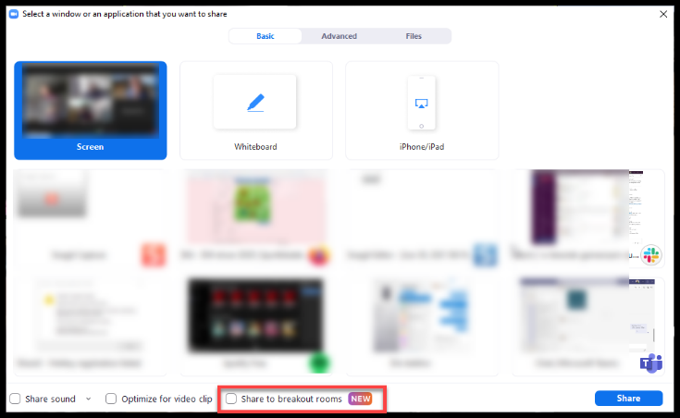
1. Click Share Screen in the meeting controls.
2. Enable the Share to breakout rooms option along the bottom of the share window.
3. Choose what you would like to share, including an entire screen, a specific open program, or others.
4. (Optional) Click the Share Sound option as well to include audio with the shared content.
5. Click Share. The selected content will be shared to all breakout rooms. Any active shares in any breakout rooms will be interrupted for the host's/co-host's shared screen. Annotation or whiteboarding is saved before the host's shared content is viewed.

8. Vocabulary Lesson #3. Travel vocabulary. Ahora aprenderemos vocabulario relacionado con viajar. Now we are going to talk about travel vocabulary.

- Useful questions, answers and phrases when traveling
VOCABULARIO DE VIAJE | TRAVEL VOCABULARY
el boleto | ticket
el avión | airplane
viajar | to travel
el pasaporte | passport
la fila | line
el asiento | seat
el taxi | taxi
el carro /el coche | car
el autobús /el bus | bus
la parada de autobús | bus stop
el conductor/la conductora | bus driver
los pasajeros | passengers
las monedas | coins
la propina | tip
la ciudad | city
alto | stop
girar /gire /doble | to turn around /turn around
seguir /sigue | to continue, to keep going
la derecha | right
la izquierda | left
derecho, recto | straight
el mapa | map
Aquí está… | Here is…

9. Más Práctica Escrita – Written practice! Fill out the blanks. Use the vocabulary chart from above as reference.

- Para ir en _________________, necesito ________________ (To go on an airplane, I need a ticket).

- Necesito _________________ para ________________ a otros países. (I need my passport to travel to other countries).

- ¿Prefieres viajar en ________________ o _________________? (Do you prefer to travel by bus or car?)

- Cuando subo al __________________, saludo al _________________ diciendo _____________________ (When I get in the taxi, I greet the driver, by saying “good afternoon”).

- Hay muchos ___________________________ en este viaje. (There are lots of passengers on this trip.)

10. Whole class actvity! Empareja las palabras. Match the words. Match the Spanish words with the correct English meaning. Use the vocabulary chart from above as reference.

- gire a. map
- la fila b. airplane
- el mapa c. seat
- el asiento d. turn around
- el avión e. line
- la ciudad f. ticket
- el boleto g. city
- las monedas h. coins

11. More Conversation Practice! - ¡Vamos a conversar! Review the conversation from the PowerPoint visual and ensure that participants understand the questions and answers. *Remember to see the note from above related to breakout rooms.

12. OPTIONAL NOTA CULTURAL: How to catch a taxi in Spanish? If time, screenshare this YouTube video that provides some useful phrases on how to hire a taxi service in Spanish. https://youtu.be/fme80oG3CwQ?si=d6y8AVbO_d1m9u0c

13. OPTIONAL: TAREA /Homework Encourage participants to use the Quizlet links provided in their handout to review the material covered in today’s lesson. Please, remind them that they can access Futura’s portal to review the lesson with the visuals and other materials as well.

