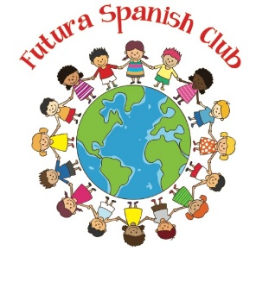

e 
Futura Language Professionals
www.FuturaAdventures.com

Day 3
Spanish Newsletter

Vocabulary List
el marciano; el extraterrestre – martian; alien
la Tierra - Earth
el cometa – comet
la gravedad - gravity
flotar – to float
volar – to fly
verde – green
azul – blue
amarillo – yellow
rojo – red
rosado – pink
morado - purple
anaranjado – orange
negro – black

Conversation Practice
¿Cómo estás? – How are you?
Bien, mal, más o menos – Good, bad, okay
Yo puedo… - I can…

¡Vamos por la Galaxia!
Information
Visit the Parent Portal on our website for additional practice opportunities. Please contact the Futura Language Professionals Coordinator, coordinator@FuturaAdventures.com with any questions about Spanish class.
In this fun, galaxy-themed culture lesson, students blasted off into the world of space and sci-fi, discovering how Hispanic cultures celebrate favorites like Star Wars (La Guerra de las Galaxias). They shared favorite characters, practiced Spanish with Yoda and Grogu, and explored shows like WALL-E, Lightyear, and Elio, a Pixar film featuring a Latino family. They also learned about Mexican folklore, including the rabbit on the moon and alien sightings near volcanoes—blending imagination, culture, and language in a way that was out of this world!

Notas Culturales
Today students practiced Spanish conversation skits meeting aliens and talking about planets.

