1. Ice Breakers & Get to know each other conversation practice to get started.
- Invite your students to introduce themselves to the class in Spanish, encourage them to share ¿Qué haces? ¿Por qué estudias español? What do you do? Why do you study Spanish? *Goal to encourage participants to speak/practice Spanish. Remember that students may have different levels in the Spanish language, so feel free to screen share the PowerPoint visual with the Q&A or use the whiteboard.

- Important: provide a clear and consistent bilingual approach with Spanish first (slow and enunciated) and English translations to help participants follow along.
3. Vocabulary Lesson #1: EL VERBO TENER -to have. Vamos a repasar el verbo tener y aprender en qué contextos se utiliza este verbo. We are going to review the TENER verb and learn the different contexts when it is used.
TENER – to have
SINGULAR PLURAL
yo | tengo | nosotros, nosotras | tenemos
tú | tienes | vosotros | tenéis
él, ella, usted | tiene | ellos, ellas, ustedes | tienen

- Age/ edad | Tengo 20 años. (I´m 20 years old.)  Mi hijo tiene 2 años. (My son is 2 years old.)
- Assets / Property | Tengo una casa. (I have a house.)  Tengo 2 carros. (I have 2 cars.)
- Characteristics | Tengo pelo café. (I have brown hair.)  La blusa tiene 2 bolsas. (The blouse has 2 pockets.)  La caja tiene 5” de largo (The box is 5” long.)
- States of being and needs | Tengo sueño. (I’m sleepy.)  Tengo dolor de… (I have a pain in...)  Tengo hambre. (I’m hungry.)  Tengo ganas de pastel. (I feel like having cake.)
- Obligation | Tengo que bañarme. (I have to take a shower.)  Tengo una junta. (I have a meeting.)  Tengo que hacer la cena. (I have to make dinner.)
- Relationships | Tengo 2 hijos. (I have 2 children.)  Tengo novio. (I have a boyfriend.)

4. Vocabulary Lesson #2: LA COMIDA -Food and Dining. Vamos a aprender vocabulario acerca de la comida. We are going to learn about food and dining out vocabulary. Use the PowerPoint visual to teach the vocabulary and encourage participants to repeat the Spanish after you.

COMIDA | FOOD | COMIDA | FOOD
el desayuno | breakfast | el pescado | fish
el almuerzo | lunch | el arroz | rice
la cena | dinner | los frijoles | beans
la bebida | drink | el café | coffee
el postre | dessert | el jugo | juice
los huevos | eggs | la cerveza | beer
el bocadillo /la merienda | snack | el agua | water
el pan | bread | la leche | milk
el sándwich | sandwich | el helado | ice cream
las papas fritas | chips /fries | el restaurante | restaurant
las papas a la francesa | french fries | y | and
las verduras | vegetables | con | with
la fruta | fruit | para llevar | to go
la sopa | soup | el dólar /los dólares | dollar /dollars
la ensalada | salad | el centavo /los centavos | cent /cents
el bistec | beef /steak | el cambio / el efectivo | change or cash
el pollo | chicken

Builder Phrases: Dining Out
- ¿Cuánto cuesta? How much is it? ¿Cuánto cuestan? How much are they?
- ¿Qué le gustaría para comer? What would you like to eat?
- Me gustaría… I would like… Me gusta… I like… No me gusta… I don’t like…
- ¿Tiene_____? Do you have______? ¿Qué tiene para______? What do you have for____?
- ¡Qué rico! How yum! Delicious! Bueno Good Malo Bad (as it refers to food)
- ¿Hay….? Is/Are there any….? ¿No hay? There isn’t?
- ¿La cuenta por favor? The check please? ¿Cuánto es? How much is it?
- Precio Price, costo cost, cambio exchange, descuento discount, propina tip
- Pago en efectivo. Pay with cash., Pago con tarjeta de crédito. Pay with credit card.
- Buen provecho/ Provecho Enjoy your meal.
- Vamos a desayunar, almorzar, cenar Let’s go to have breakfast, lunch, dinner.
- Tengo hambre I’m hungry
- Por favor Please, Gracias thank you De nada you’re welcome Disculpe excuse me

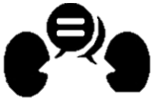
5. CONVERSATION PRACTICE - ¡Vamos a conversar! In the following conversation, you will review lots of vocabulary about food and dining out. Let’s get ready to join the breakout rooms and practice with a partner. *Feel free to change the underlined parts for different food and drink!

NOTE: Please notice how your students respond when breakout rooms come up. -It is okay to keep the class together in the main session for the conversation practice instead of sending everybody to breakout rooms.

CONVERSACIÓN | CONVERSATION
Mesero/a:  —¡Buenas tardes! Bienvenido al restaurante “El Beso”.  Comensal:  —Muchas gracias. ¡Tengo hambre!  Mesero/a:  —¿Qué le gustaría ordenar para el almuerzo?  Comensal:  —Me gustaría ordenar la carne, la ensalada y las papas a la francesa.  Mesero/a:  —Excelente elección. ¿Y qué le gustaría de beber?  Comensal:  —¿Tiene bebidas calientes?  Mesero/a:  —Si, y bebidas frías también.  Comensal:  —Me gustaría un café con leche, por favor.  Mesero/a:  —Con gusto, ya regreso. (The server goes to the kitchen and comes back with your order) | Server:  —Good afternoon! Welcome to the restaurant “El Beso”.  Diner:  —Thank you very much. I’m starving!  Server:  —What would you like to order for lunch?  Diner:  —I would like to try the meat, the salad, and the French fries.  Server:  —Excellent choice. And what would you like to drink?  Diner:  —Do you happen to have hot drinks?  Server:  —Yes, I do. We have cold drinks as well.  Diner:  —I would like a coffee with milk, please.  Server:  —With pleasure, I’ll be right back. (The server goes to the kitchen and comes back with your order.)
Comensal:  —¡Qué rico! Todo se ve bueno. Gracias.  Mesero/a:  —De nada. ¡Buen provecho! (The server goes to serve someone. Then you finished your meal, and you say…)  Comensal:  —Disculpe. ¿La cuenta, por favor?  Mesero/a:  —¿Su pago será en efectivo o con tarjeta de crédito?  Comensal:  —Con tarjeta de crédito.  — (You have paid and left a tip on the table for the waiter, you start getting ready to leave and say…) En la mesa está la propina. ¡Hasta luego!  Mesero/a:  Muchas gracias por la propina. ¡Hasta la vista!  EL FIN | Diner:  —How yum! Everything looks good. Thank you.  Server:  —You’re welcome. Enjoy your meal! (The server goes to serve someone. Then you finished your meal, and you say…)  Diner:  —Excuse me. The check, please?  Server:  —Your payment would be cash or credit?  Diner:  —With credit card.  —(You have paid and left a tip on the table for the server; you start getting ready to leave and say…). The tip is on the table. See you later!  Server:  —Thank you very much for the tip. See you soon!  THE END

6. Vocabulary Lesson #2: EL VERBO GUSTAR -The verb TO LIKE. Vamos a aprender el verbo gustar y sus conjugaciones. We are going to learn the GUSTAR verb and its conjugations.
Watch the ME GUSTA video to have a better context about this verb.
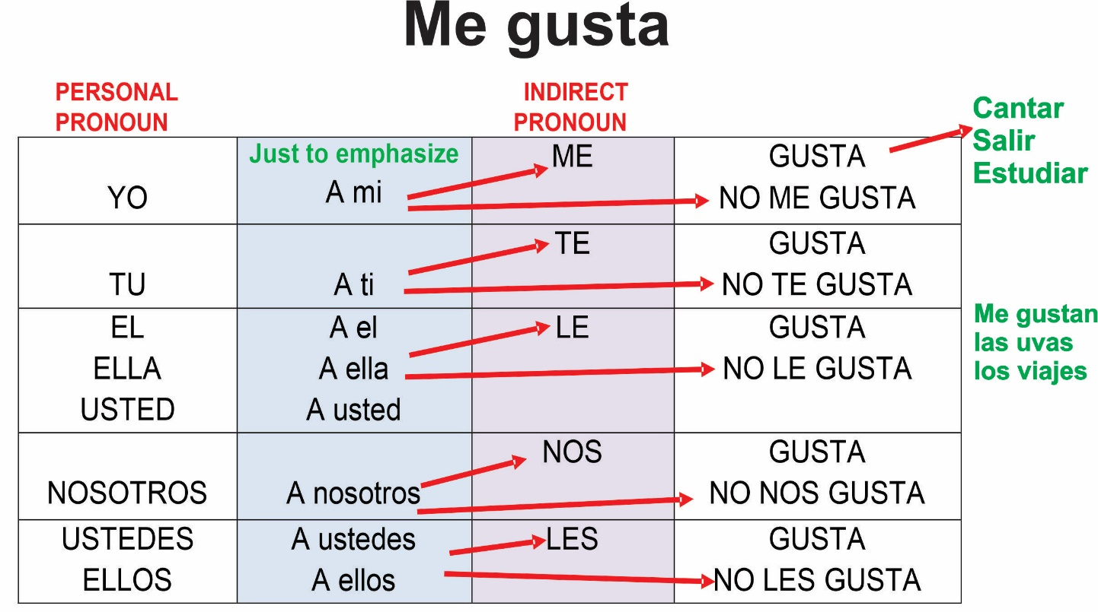

7. NOTA CULTURAL – Culture note. The verb gustar means “to please”. Use it to express that someone likes something.

Negatives: To answer a question negatively in Spanish, you often use no twice.
The first no answers the question. The second no is used to express don’t.
In Spanish you use double negatives.

- ¿Te gusta el café? No, no me gusta. Do you like coffee? No, I don´t.
- ¿Te gusta el pescado? No, no me gusta para nada. Do you like fish? No, I don´t like it at all.
- No me gusta ni la sopa ni la ensalada. I don’t like neither soup nor salad.
Expressing agreement or disagreement:
Type of statement | Example | You agree | You disagree
Positive | Me gusta el pollo. | A mí también | A mí no me gusta
Negative | No me gusta el pollo. | A mí tampoco | A mí sí me gusta

- Use me gusta when talking about singular nouns.
Example:
¿Te gusta el postre? Sí me gusta el postre. *el postre is a singular noun.

- Use me gustan (with the n at the end) when talking about a plural noun.
Example:
¿Te gustan las verduras? Si, me gustan las verduras. *las verduras is a plural noun.


8. WHOLE CLASS ACTIVITY. A mí TAMBIÉN or a mí TAMPOCO

Everyone in class will share something they like and follow the pattern.

1. Person A: Me gusta la sopa. Person B. A mí también me gusta. OR A mí no me gusta la sopa.

2. Person A: No me gusta el agua. Person B: A mí tampoco me gusta. OR A mí si me gusta.

9. OPTIONAL: TAREA /Homework. Encourage participants to use the Quizlet links provided in their handout to review the material covered in today’s lesson. Please, remind them that they can access Futura’s portal to review the lesson with the visuals and other materials as well.

