1. Ice Breakers & Get to know each other conversation practice to get started.
- Invite your students to introduce themselves to the class in Spanish, encourage them to share ¿Te gusta tomar jugo? ¿Pagas con efectivo o con tarjeta de crédito? Do you like drinking juice? Do you pay in cash or with a credit card? *Goal to encourage participants to speak/practice Spanish. Remember that students may have different levels in the Spanish language, so feel free to screen share the PowerPoint visual with the Q&A or use the whiteboard.

- Important: provide a clear and consistent bilingual approach with Spanish first (slow and enunciated) and English translations to help participants follow along.


- CONVERSATION PRACTICE: FOOD AND DINING REVIEW. In the following conversation, you will review lots of vocabulary about food and dining out. Let’s get ready to join the breakout rooms and practice with a partner. *Feel free to fill in the spaces before we go to the breakout rooms in zoom.

NOTE: Please notice how your students respond when breakout rooms come up. -It is okay to keep the class together in the main session for the conversation practice instead of sending everybody to breakout rooms.


Planeando salir a comer – Planning dining out

1. Vamos a comer ________. Let’s go eat breakfast, lunch OR dinner
2. Si, vamos. ¡Tengo hambre! Yes, let’s go. I am hungry!
1. Te gusta el restaurante_________. Do you like the restaurant_______.
2. Si, me gusta ____ OR No, no me gusta_____. Yes, I like it. OR No, I don’t like it.


En el restaurante - At the restaurant
1. ¿Qué le gustaría comer? What would you like to eat?
2. Me gustaría _______ y ________. I would like_________ and _______.
1. ¿Cuánto cuesta______? OR ¿Cuánto cuestan______? How much does it cost? How much do they cost?

2. Cuesta $____dólar/dólares It cost____dollars.

Comiendo- Eating
1. Mmm… ¡Qué rico! Mmm… How delicious!
2. Si. ¡Buen provecho! Yes. Enjoy your meal!


Hora de pagar - Time to pay
1. Disculpe. La cuenta, por favor. Excuse me. The check, please.
2. Aquí tiene. Pago solo en efectivo. Here you go. Pay in cash only.
1. ¿Cuánto es? How much is is?
2. Es ____ dólares y ____ centavos. It is ____dollars and ___ cents.
1. Gracias. Thank you.

4. LA GRAMÁTICA -GRAMMAR.
¿El o la? Gender of Spanish Nouns
- Gender can be determined by word meaning. The word for “man” will be masculine; for “woman” will be femenine: El hombre/la mujer. Some words that are otherwise very similar will change the article and sometimes shift slightly in spelling to reflect gender: el estudiante/la estudiante, el profesor/la profesora.

- Languages, rivers, oceans, days of the week and months of the year are masculine

- Often, words ending in d, ión, z and a are feminine. These are sometimes referred to as “DIONZA” (d-ión-z-a) words to help you remember which endings are often (but not always!) feminine. So, DIONZA, (d-ión-z-a) endings are feminine.

- Often (but not always!), words ending in “LONER” (l,o,n,e,r) are masculine. These may be referred to as “loner” words to help you remember the key endings. So, LONER (l-o-n-e-r) endings are masculine.
- Remember that definite & indefinite articles (el , la, los las, un, uno, unas, unos, etc) also singular or plural have to match the noun in masculine or feminine. Ej. La casa, las casas, el parque, los parques, etc.

In the chart, write down some examples of nouns. Use the vocabulary words learned in prior classes (places, food, clothing, etc.)
FEMININE | MASCULINE
D-  I-  O-  N-  Z-  A- | L-  O-  N-  E-  R-

- Verbs Review: ESTAR, SER, TENER, GUSTAR.
NOTE: encourage participants to volunteer in sharing to the class (out loud) one of the sentences they wrote down for each verb. *You can also do breakout rooms and invite participants to share all the sentences and see if the other participants understand. They can both share their work with a partner.

Verbo ESTAR – to be
Person | Singular
1rst | I am | Yo estoy
2nd | you are informal | tú estás
3rth | he /she /you formal /it is | él /ella /usted /ésto está
 | plural
1rst | we are | nosotros estamos
2nd | you (all) formal are  you (all) informal are | ustedes están  vosotros estáis
3rth | they are (all boys or mixed)  they are (all girls) | ellos están  ellas están

Examples:
- Yo estoy en la biblioteca. I am in the library.
- ¿Dónde está? Where is it?
- ¿Cómo está el clima? What is the weather like today?

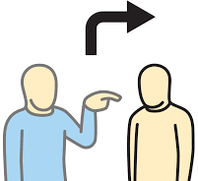
Now it is your turn. Write 3 sentences using the verb ESTAR. Use the chart and examples from above as reference.
- __________________________________________________________________________
- __________________________________________________________________________
- __________________________________________________________________________
SER – TO BE

SINGULAR PLURAL
I am | yo soy | we are | nosotros somos
you are (informal) | tú eres | you all are (informal) | vosotros sóis
he is | él es | they (all male or mix) | ellos son
she is | ella es | they (all female) | ellas son
it is | esto es | you all are (formal) | ustedes son
you are (formal) | usted es
D – Description (physical characteristics) tall, blond, brunette
O – Origin/Nationality (from Mexico, Mexican)
C – Characteristics (personality) (shy, outgoing, funny)
T – Time (It’s 5:00PM, It’s 3:30AM)
O – Occupation (teacher, doctor, etc.)
R – Relationships (friends, siblings, family)

Examples:
- Somos altos. We are tall.
- Ellos son de México. They are from Mexico.
- Ella es muy tímida. She is very shy.
- Son las dos y media. It is 2:30.
- Tú eres ingeniero. You are an engineer.
- Él es mi hermano. He is my brother.

Now it is your turn. Write 3 sentences using the verb SER. Use the chart and examples from above as reference.
- __________________________________________________________________________
- __________________________________________________________________________
- __________________________________________________________________________

TENER – to have
SINGULAR PLURAL
yo | tengo | nosotros, nosotras | tenemos
tú | tienes | vosotros | tenéis
él, ella, usted | tiene | ellos, ellas, ustedes | tienen

Examples:
- Yo tengo un carro. I have a car.
- Tú tienes una casa. You have a house.

Now it is your turn. Write 3 sentences using the verb TENER. Use the chart and examples from above as reference.
- __________________________________________________________________________
- __________________________________________________________________________
- __________________________________________________________________________

Watch the ME GUSTA video to have a better context about this verb.
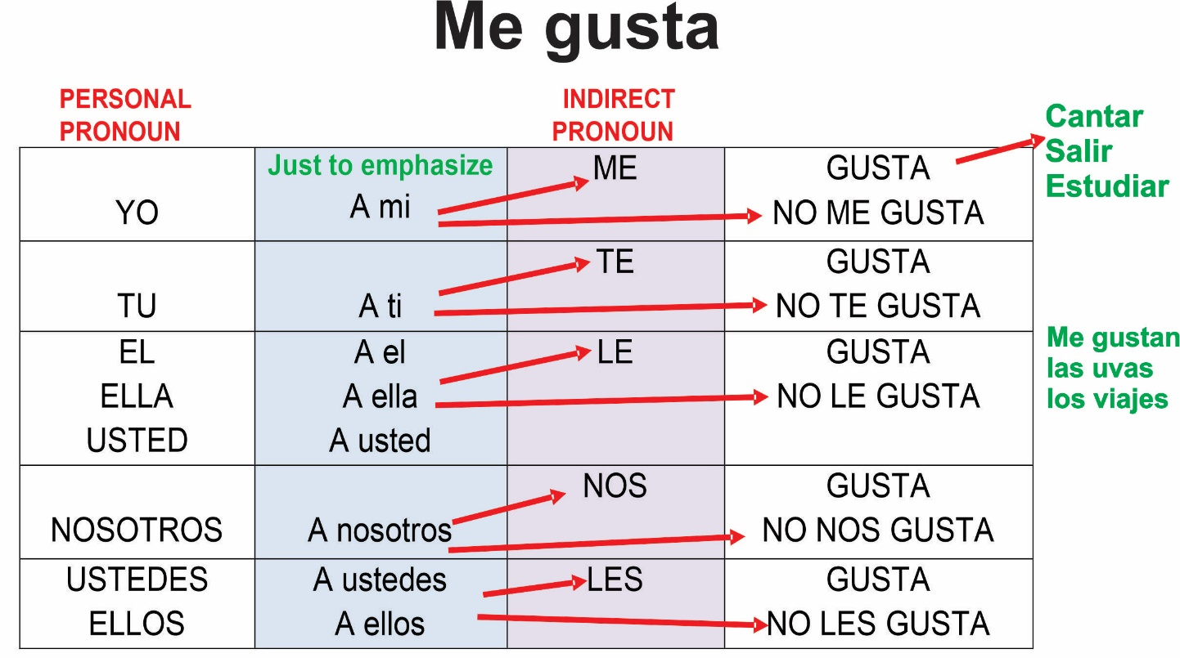

Examples:
- Me gusta el pollo. I like chicken.
- A ellos les gusta el pescado. They like the fish.

Now it is your turn. Write 3 sentences using the verb TENER. Use the chart and examples from above as reference.
- __________________________________________________________________________
- __________________________________________________________________________
- __________________________________________________________________________

6. Conversación / Conversation Practice: The goal of this review practice is to incorporate the verbs learned: SER, ESTAR, TENER, AND GUSTAR in a conversation setting.

NOTE: Please notice how your students respond when breakout rooms come up. -It is okay to keep the class together in the main session for the conversation practice instead of sending everybody to breakout rooms.

1. ¿Qué te gusta hacer? What do you like to do? _____________________________________________
2. ¿Cómo eres? How would you describe yourself? ____________________________________________
3. ¿Cómo estás? How are you feeling? _____________________________________________________
4. ¿Tienes hermanos? Do you have siblings? ________________________________________________
5. ¿Qué te gusta más? What do you like better? ______________________________________________
6. ¿Te gusta tu trabajo? Do you like your job/work? ___________________________________________
7. ¿Tienes mascotas? Do you have pets? ___________________________________________________
8. ¿Cómo es tu mascota? How would you describe your pet? ___________________________________
9. ¿Cómo está el clima hoy? What is the weather like today? ___________________________________
10. ¿Cuántos años tienes? How old are you? __________________________________________________
11. ¿De dónde eres? Where are you from? ____________________________________________________

7. OPTIONAL: TAREA /Homework. Encourage participants to use the Quizlet links provided in their handout to review the material covered in today’s lesson. Please, remind them that they can access Futura’s portal to review the lesson with the visuals and other materials as well.

