
Costa Rican Oxcart
Color la carreta (oxcart) from Costa Rica. Be creative and use lots of colors!

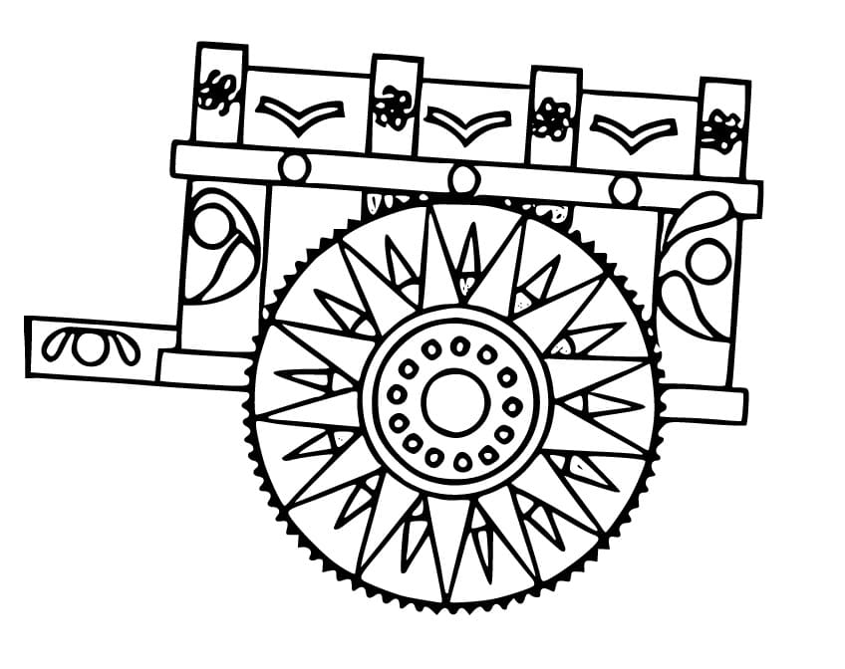

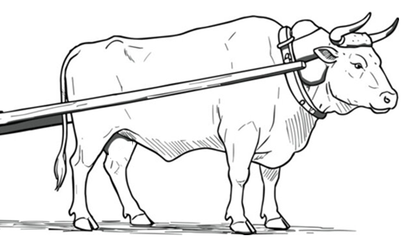


Create Your Own Costa Rican Oxcart
Based on what you learned today about Costa Rica’s oxcart, design your own carreta (oxcart). Be creative and use lots of colors!

