1. Ice Breakers & Get to know each other conversation practice to get started.
- Invite your students to answer the following questions ¿Qué te gustaría comer ahora? Menciona 2 utensilios que necesitas para poner la mesa. What would you like to eat? Mention 2 elements that you need for setting up the table. (This can be made easy or more challenging, depending on participants’ level.) *Goal to encourage participants to speak/practice Spanish. Remember that students may have different levels in the Spanish language, so feel free to screen share the PowerPoint visual with the Q&A or use the whiteboard.
- Important: provide a clear and consistent bilingual approach with Spanish first (slow and enunciated) and English translations to help participants follow along.

2. Vocabulary Lesson #1: Vamos a iniciar la clase aprendiendo vocabulario relacionado con las compras. Let’s start the class by learning some shopping vocabulary. COMPRAR -TO BUY /TO SHOP

VOCABULARIO DE COMPRAS | SHOPPING VOCABULARY
¿Cuánto cuesta…? | How much is…?
Quiero… | I want…
¿Tienes…? | Do you have…?
Necesito…. | I need…
el dinero | money
el efectivo | cash
los dólares | dollars
los centavos | cents
el cambio /el vuelto | change
el banco | bank
la casa de cambio | exchange bank
cambiar ($) | to exchange ($)
el precio | price
el cajero automático | the ATM
el mercado | market
la tienda | store
el supermercado | supermarket /grocery store
el recuerdo /un recuerdito | souvenir / a souvenir
la artesanía | crafts/handicraft

3. Práctica Escrita – Written practice! Fill in the blanks with the correct Spanish answers. Use the chart from above for reference.

- Do you have cash? _______________________________________________________________________
- I need dollars and cents. __________________________________________________________________
- How much does the souvenir cost? ________________________________________________________
- I want to go to the market. _________________________________________________________________
- I need the bank or the ATM. ________________________________________________________________

4. Whole class activity! La Ruleta Adivinadora -Randomizer! Use this Randomizer to review the content from the above chart. Invite your students to share the answers in Spanish! *Use as many or as little as you consider best for your group and consider the time available.

5. Vocabulary Lesson #2: Ahora aprenderemos vocabulario relacionado con los números. Now we are going to learn Spanish numbers! -Use the PowerPoint visual to teach the vocabulary and encourage participants to repeat after you.

VOCABULARIO DE NÚMEROS
Number Vocabulary

0 | cero | 10 | diez | 20 | veinte
1 | uno | 11 | once | 30 | treinta
2 | dos | 12 | doce | 40 | cuarenta
3 | tres | 13 | trece | 50 | cincuenta
4 | cuatro | 14 | catorce | 60 | sesenta
5 | cinco | 15 | quince | 70 | setenta
6 | seis | 16 | dieciséis | 80 | ochenta
7 | siete | 17 | diecisiete | 90 | noventa
8 | ocho | 18 | dieciocho | 100 | cien
9 | nueve | 19 | diecinueve | 100 | cien

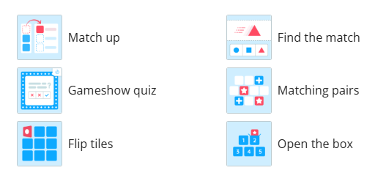
6. Whole class activity! Worwall Activity! Use this Wordwall game to review Spanish numbers. Invite your students to share the answers in Spanish! * Feel free to select any of the many choices to play this game (see image).

7. Conversation practice - ¡Vamos a conversar! Breakout rooms. In the following conversation, your students will use lots of vocabulary about las compras and los números. Model the conversation first and then invite them to join the breakout rooms and practice with a partner.

NOTE: Please notice how your students respond when breakout rooms come up. -It is okay to keep the class together in the main session for the conversation practice instead of sending everybody to breakout rooms.
CONVERSACIÓN | CONVERSATION
Vendedor:  —¡Buenos días, amigo!  Cliente:  —Hola. Buenos días.  Vendedor:  —¿Qué necesitas?  Cliente:  —Necesito comprar recuerditos para mi familia.  Vendedor:  —Tengo muchas artesanías. Mira estas… (The seller points at the handicrafts and shows them to you)  Cliente:  —¡Me encanta! ¿Cuánto cuestan?  Vendedor:  —Cuestan $45 pesos cada una.  Cliente:  —Quiero dos, por favor. Pero necesito cambiar mis dólares por pesos.  Vendedor:  —Puedes ir al banco o al cajero automático.  Cliente:  —¿Sabes en dónde están?  Vendedor:  — Sí, a la derecha de la tienda de comida.  Cliente:  —¡Muchas gracias! Ya regreso. (You got cash and came back to the store)  Vendedor:  —Aquí están sus artesanías.  Cliente:  —Te lo agradezco. ¿Cuánto es?  Vendedor:  —Son $90 dólares y $0.50 centavos.  Cliente:  —Gracias. ¡Hasta la próxima!  Vendedor:  —¡Gracias a usted por su compra! Nos vemos. | Vendor:  —Good morning, my friend!  Customer:  —Hi. Good morning.  Vendor:  —What do you need?  Customer:  —I need to buy souvenirs for my family.  Vendor:  —I have lots of handicrafts. Look at these… (The seller points at the handicrafts and shows them to you)  Customer:  —I love them! How much do they cost?  Vendor:  —They cost $45 dollars each.  Customer:  —I want two, please. But I need to exchange my dollars for pesos.  Vendor:  —You can go to the bank or the ATM.  Customer:  —Do you know where they are?  Vendor:  —Yes, to the right of the food store.  Customer:  —Thank you very much! I’ll be right back. (You got cash and came back to the store)  Vendor:  —Here are your handicrafts.  Customer:  —I appreciate it. How much is it?  Vendor:  —It’s $90 pesos and 50 cents.  Customer:  —Thanks. See you next time!  Vendor:  —Thank you for your purchase! See you.

8. NOTA CULTURAL: El Mercado de Chichicastenango. Chichicastenango Market!
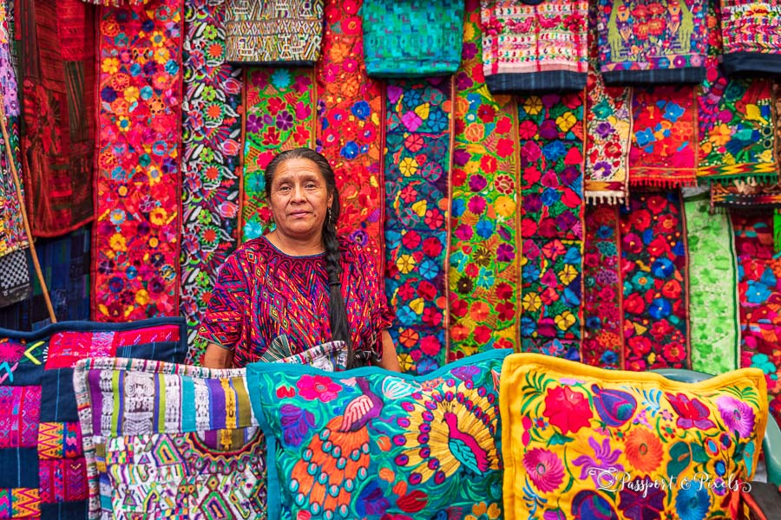
Perched on a high mountain ridge encircled by a pine forest, the Quiche Maya town of Chichicastenango in Guatemala hosts the most famous indigenous market in Central America. Chichicastenango is renowned for its vibrant, open-air market and for its rich Mayan culture and religious practices. On Sundays and Thursdays, its central plaza overflows with fresh flowers, traditional foods, colorful handcrafts and practical housewares. The town is a center for K'iche' Maya traditions, with its market serving as a meeting point for villagers from surrounding areas.

Though the ride involves winding mountain roads, the views are breathtaking and well worth the journey. Chichicastenango Market is more than just a marketplace; it's a vibrant cultural hub where centuries-old traditions come alive. The journey to get there is as much a part of the experience as the market itself.

If time, screenshare this YouTube video that talks about Chichicastenango Market. Here is another video with colorful images from this market shared by a tourist perspective exploring Guatemala's largest market.

9. OPTIONAL: TAREA /Homework Encourage participants to use the Quizlet links provided in all their handout to review the material covered during summer classes!


10. IMPORTANT GOODBYE NOTE (use this note from day 4 only if you are teaching this class during summer): Please, thank the participants for their hard work and participation. Encourage them to continue taking Futura's Spanish classes for the upcoming semester. -At this point, your manager has shared with you a promotional flyer for the upcoming classes. Please, screen share this information with the participants and listen to any questions they may have. Thank you!

