1. Ice Breakers & Get to know each other conversation practice to get started.
- Invite your students to answer the following question using last week’s vocab: ¿Cuáles son 2 cosas indispensables que debes tener listas antes de viajar? (This can be made easy or more challenging, depending on participants’ level.) *Goal to encourage participants to speak/practice Spanish. Remember that students may have different levels in the Spanish language, so feel free to screen share the PowerPoint visual with the Q&A or use the whiteboard.
- Important: provide a clear and consistent bilingual approach with Spanish first (slow and enunciated) and English translations to help participants follow along.
2. Vocabulary Lesson #1: Vamos a iniciar la clase aprendiendo más vocabulario relacionado con los viajes. Let’s start the class by learning more travel vocabulary. TURISTA = TOURIST

VOCABULARIO DE VIAJE | TRAVEL VOCABULARY
el equipaje | the luggage
la maleta | the suitcase
la mochila | the backpack
la bolsa | the purse/ bag
la billetera | the wallet
las llaves | the keys
la cámara | the camera
las gafas del sol / los lentes de sol | the sunglasses
la sombrilla/ el paraguas | the umbrella
el traje de baño | the swimsuit
el bloqueador | the sunscreen
los zapatos | the shoes
las chanclas/ las sandalias | the flip flops/sandals
la chaqueta/ la chamarra (only in Mexico) | the jacket
la camisa | the shirt
la playera/ la camiseta | the t-shirt
los pantalones | the pants
los pantalones cortos | the shorts
el vestido | the dress
la falda | the skirt
cómodo | comfortable
llevar | to bring
meter | to put… in
sacar fotos | to take pictures
hacer las maletas | to pack your luggage
empacar | to pack
organizar | to organize
olvidar | to forget
necesitar | to need

3. Práctica Escrita – Written practice! Fill in the blanks with the correct Spanish answers. Use the chart from above for reference. IMPORTANT: A = UN or UNA – MI = MY

- Necesito_________________________________________ y llevar ___________________________ conmigo.
- I need to pack my luggage and take the umbrella with me.

- ¡Ya quiero ir a la piscina! Tengo que ____________________________: el __________________________y el_________________________________________________.
- I can’t wait to go to the pool! I must pack: the sunscreen and the swimsuit.

- Empaqué _________________________________ para _____________________________________________.
- I have packed the camera to take pictures.

- No debo_______________________: ___________________________ y _______________________________.
- I shouldn’t forget the wallet and my keys!

- La ropa que necesito para mi viaje es: _______________________________, ________________________ y __________________________________. ¡Quiero estar __________________________!
- The clothes that I need for my trip are shorts, a T-shirt and sandals. I want to feel comfortable!

4. Whole class activity! PICTIONARY!
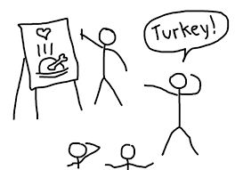
Use the space provided in the PowerPoint presentation to draw some figures related to the vocabulary learned above. -Feel free to ask for volunteers and see if your students may want to do some drawings too. You can send them the word in a private message using the chat in Zoom. *Goal is for the whole class to guess the Spanish words.

5. Vocabulary Lesson #2: Ahora aprenderemos algunas preguntas útiles que te pueden servir cuando viajes. Now we are going to learn some useful questions that may be handy when traveling. -Use the PowerPoint visual to teach the vocabulary and encourage participants to repeat after you.

CONVERSACIÓN | CONVERSATION
¿Qué necesitas empacar para el viaje? | What do you need to pack for the trip?
¿Cuándo vas a hacer las maletas? | When are you going to pack your luggage?
¿Dónde vas a ir de compras? | Where are you going to shop?
¿Qué haré el día de hoy? | What will I be doing today?
¿Tienes bastante ropa para este clima? | Do you have enough clothes for this weather?
¿Qué recomiendas llevar hoy? | What do you recommend bringing today?
¿Necesitamos los zapatos o podemos llevar las sandalias? | Do we need shoes, or can we wear sandals?

6. NOTA CULTURAL: Central and South American destinations.
If time, screen share any of the following videos with your students. These videos may help them have a better understanding of the wonders in the Spanish speaking countries.
- Countries to visit on a budget
- 15 Best Places To Visit In Central And South America

Invite them to complete the activity below and share their answers with the class.

- ¿Has viajado a algún país hispanohablante? Have you ever traveled to a Spanish speaking country?

SI NO

  - If yes, which country did you visit? ________________________________________________________________________________________

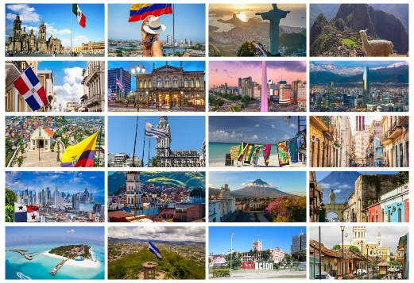
- ¿Qué países hispanohablantes te gustaría visitar en el futuro? What Spanish speaking countries would you like to visit in the future?

_________________________________________________________________________________________________________________________________________________________________________________________________________________________________________________________________________________________________________________________________________________________________________________________________________________________________________________________

7. Conversation practice - Vamos a conversar! Breakout rooms. In the following conversation, your students will use lots of travel vocabulary. This conversation will include the questions and phrases they learned today! *Model the conversation first and then invite your students to join the breakout rooms and practice with a partner.

NOTE: Please notice how your students respond when breakout rooms come up. -It is okay to keep the class together in the main session for the conversation practice instead of sending everybody to breakout rooms.

CONVERSACIÓN | CONVERSATION
Persona 1: ¿Qué necesitas empacar para el viaje?  Persona 2: Necesito empacar el vestido, los pantalones y los zapatos.  Persona 1: ¿Cuándo vas a hacer las maletas?  Persona 2: Voy a hacer las maletas mañana.  Persona 1: ¿Dónde vas a ir de compras?  Persona 2: Voy a ir de compras a la tienda y al supermercado.  Persona 1: ¿Qué haré el día de hoy?  Persona 2: Hoy iré al parque central y tomaré muchas fotos con mi cámara.  Persona 1: ¿Tienes bastante ropa para este clima?  Persona 2: Si, tengo bastante ropa. Gracias por preguntar.  Persona 1: ¿Qué recomiendas llevar hoy?  Persona 2: Te recomiendo llevar las gafas de sol y una sombrilla.  Persona 1: ¿Necesitamos los zapatos o podemos llevar las sandalias?  Persona 2: Necesitas llevar ambas cosas por si acaso. | Person 1: What do you need to pack for the trip?  Person 2: I need to pack the dress, the pants, and the shoes.  Person 1: When are you going to pack your suitcases?  Person 2: I’m going to pack the suitcases tomorrow.  Person 1: Where are you going shopping?  Person 2: I’m going shopping at the store and the supermarket.  Person 1: What will you do today?  Person 2: Today I’ll go to the central park and take lots of photos with my camera.  Person 1: Do you have enough clothes for this weather?  Person 2: Yes, I have enough clothes. Thanks for asking.  Person 1: What do you recommend bringing today?  Person 2: I recommend you bring sunglasses and an umbrella.  Person 1: Do we need shoes, or can we bring sandals?  Person 2: You need to bring both just in case.


8. IMPORTANT GOODBYE NOTE: Please, thank the participants for their hard work and participation. Encourage them to continue taking Futura's Spanish classes for the upcoming semester. -At this point, your manager has shared with you a promotional flyer for the upcoming classes. Please, screen share this information with the participants and listen to any questions they may have. Thank you!

