
Nombre________________________
REFLEXIVE VERBS AND SELF-CARE
Choose 11 common reflexive verbs from your Student Resource Page 773. In the space provided, draw and color pictures that show daily self-care habits. For each picture, write one sentence describing the action, making sure to use the correct reflexive pronoun. An example has been provided for you below to guide you.

bañarse
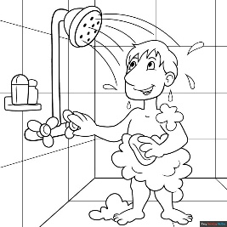

Yo me baño.

