1. Ice Breakers & Get to know each other conversation practice to get started.
- Invite your students to introduce themselves to the class in Spanish, encourage them to share their name and how they are feeling ¿Cómo te llamas? ¿Cómo estás? What is your name? How are you? (This can be made easy or more challenging, depending on participants’ level.) *Goal to encourage participants to speak/practice Spanish. Remember that students may have different levels in the Spanish language, so feel free to screen share the PowerPoint visual with the Q&A or use the whiteboard.
- Important: provide a clear and consistent bilingual approach with Spanish first (slow and enunciated) and English translations to help participants follow along.
2. Show the participants the Futura website & Parent Portal – Screenshare the adult tab so they can easily see where to get the handouts and information for the class online. If they haven’t downloaded the handout, encourage them to do so for ease of conversation practice during class. Screen share the steps on the website directly or the document “Adult steps to Login to Parent Portal.” ***The participants will not receive further emails with any handouts as they are to access this on the website.

3. Vocabulary #1. Vamos a repasar los pronombres personales. We are going to review the subject pronouns.
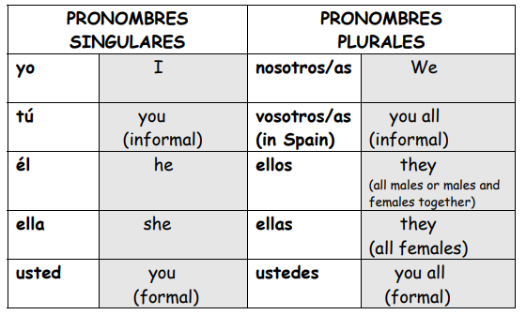

4. Vocabulary #2. Vamos a aprender verbos en infinitivo y sus reglas de conjugación. We are going to learn infinite verbs and conjugation rules.
Infinitive verbs:
In Spanish, infinitives always end in -ar, -er or -ir. In English, "infinitive" is usually used to refer to the "to + verb" form of the verb such as "to run" or "to eat.

Examples:
ENGLISH INFINITIVE | SPANISH INFINITIVE
to hug | abrazar
to eat | comer
to open | abrir

Conjugation AR, ER, IR verbs:
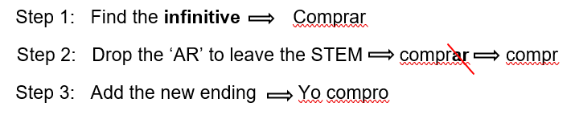

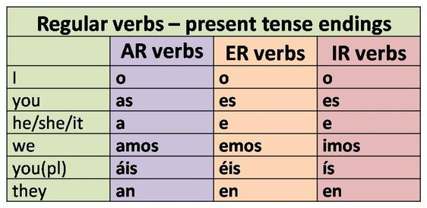

abrazar | to hug | explicar | to explain | aprender | to learn
ayudar | to help | ganar | to win | beber | to drink
bailar | to dance | gastar | to spend | comer | to eat
besar | to kiss | hablar | to talk/speak | comprender | to understand
buscar | to look for | limpiar | to clean | correr | to run
cambiar | to change | llamar | to call | creer | to believe
cantar | to sing | llegar | to arrive | leer | to read
comprar | to buy | llevar | to wear | aprender | to learn
contestar | to answer | mirar | to watch/look at | abrir | to open
descansar | to rest | nadar | to swim | decidir | to decide
dibujar | to draw | preguntar | to ask | discutir | to discuss
enviar | to send | regresar | to return | escribir | to write
escuchar | to listen | trabajar | to work | recibir | to receive
esperar | to wait for | viajar | to travel | subir | to climb/go up
estudiar | to study | visitar | to visit | vivir | to live

Infinitive verb vs conjugated verb:
INFINITIVE VERB | SUBJECT PRONOUN | CONJUGATED VERB
comprar (to buy) | yo | yo compro
correr (to run) | tú | tu corres
estudiar (to study) | él, ella, usted | el, ella, usted, estudia
creer (to believe) | nosotros | nosotros creemos
preguntar (to ask) | ustedes | ustedes preguntan
llamar (to call) | ellos | ellos llaman

Regular verbs have the same stem and when conjugated the stem keeps the same only the endings change.
5. PRÁCTICA ESCRITA – Written practice! Translate the following verb conjugations using the Spanish subject pronouns and the verb conjugation rules.

- I travel _________________________________________________________
- You (formal) sing _________________________________________________________
- We eat _________________________________________________________
- He works _________________________________________________________
- You (informal) arrive _________________________________________________________
- They (male) drink _________________________________________________________
- She writes _________________________________________________________
- I understand _________________________________________________________
- You all (informal) wait _________________________________________________________
- They (female) visit _________________________________________________________
- You all (formal) return _________________________________________________________
- We work _________________________________________________________

6. CONVERSATION PRACTICE - ¡Vamos a conversar! Review the conversation starters form the PowerPoint visual and ensure participants understand the questions and answers.
- Option 1- (if a small class or more beginner level) Keep the class as a group and screen share – having participants take turns asking/answering the questions. Depending upon the level of the participants, help them through the answers.
- Option 2- (if a larger class or more advanced) After screen sharing and brief review of conversation topics, divide them into pairs or small groups to practice in break out rooms. Use the feature of screen sharing during the breakout rooms so they can see the questions during the breakout.

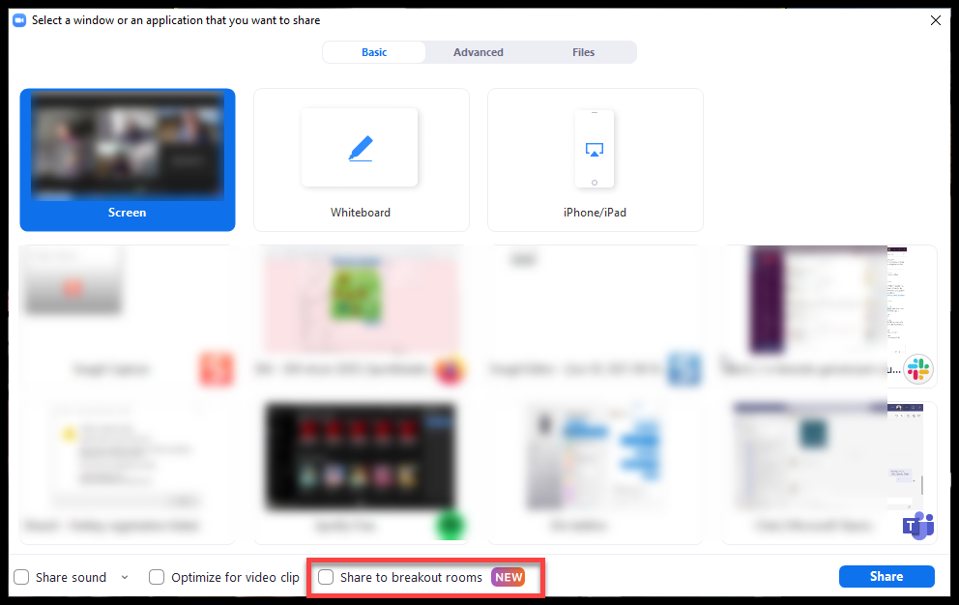
How to share your screen with all meeting breakout rooms:
1. Click Share Screen in the meeting controls.
2. Enable the Share to breakout rooms option along the bottom of the share window.
3. Choose what you would like to share, including an entire screen, a specific open program, or others.
4. (Optional) Click the Share Sound option as well to include audio with the shared content.
5. Click Share. The selected content will be shared in all breakout rooms. Any active shares in any breakout rooms will be interrupted for the host's/co-host's shared screen. Annotation or whiteboarding is saved before the host's shared content is viewed.

7. Más Verbos! More Verbs!
AR ER IR

amar | to love |  | comer | to eat |  | Vivir | to live
comprar | to buy |  | crecer | to grow |  | escribir | to write
estudiar | to study |  | aprender | to learn |  | subir | to go up/climb
caminar | to walk |  | cojer | to grab |  | Abrir | to open
necesitar | to need |  | correr | to run |  | asistir | to attend
viajar | to travel |  | deber | to owe |  | exigir | to demand
buscar | to look for |  | temer | to fear |  | existir | to exist
pensar | to think |  | escoger | to choose |  | aplaudir | to clap
llevar | to carry/take/wear |  | aprender | to learn |  | asistir | to attend
abrazar | to hug |  | vender | to sale |  | permitir | to allow

8. PRÁCTICA ESCRITA – Written practice! Fill out the blanks using the correct verb conjugations. Remember to use the vocabulary charts from above as reference.
Example:
What are you taking (llevar) to the party? ¿Qué llevas a la fiesta?

- What do you (formal) cook (cocinar)? ___________________________________________
- What do they eat (comer)?_____________________________________________________
- How do you learn (aprender) Spanish? ____________________________________________
- At what time does she leave (salir) ? ______________________________________________
- What do they need (necesitar)? _________________________________________________
- Where do they study (estudiar)?_________________________________________________
- We dance (bailar) every weekend. ________________________________________
9. More Conversation Practice! - ¡Vamos a conversar! Review the conversation from the PowerPoint visual and ensure that participants understand the questions and answers. *Remember to see the note from above related to breakout rooms.

10. EXTRA INFORMATION! Irregular Infinite Verbs. Spanish irregular infinitive verbs are verbs whose stems change when conjugated, deviating from standard patterns. Common examples include ser (to be), ir (to go), tener (to have), hacer (to do/make), and poder (to be able to), which have unique forms across various tenses and are among the most frequently used verbs.

Example PODER Example MENTIR
yo o | nosotros emos
tu es | vosotros éis
él  ella e  usted | ustedes  ellos en  ellas
yo o | nosotros imos
tu es | vosotros ís
él  ella e  usted | ustedes  ellos en  ellas

VERB CONJUGATIONS

yo puedo | nosotros podemos
tú puedes | vosotros podéis
él puede | ellos pueden
ella puede | ellas pueden
usted puede | ustedes pueden
VERB CONJUGATIONS

yo miento | nosotros mentimos
tú mientes | vosotros mentís
él miente | ellos mienten
ella miente | ellas mienten
usted miente | ustedes mienten

11. OPTIONAL TAREA /Homework. Encourage participants to use the Quizlet links provided in their handout to review the material covered in today’s lesson. Please, remind them that they can access Futura’s portal to review the lesson with the visuals and other materials as well.

