1. Ice Breakers & Get to know each other conversation practice to get started.
- Invite your students to share: Why did you decide to study Spanish? ¿Por qué decidiste aprender español? *Goal to encourage participants to speak/practice Spanish. Remember that students may have different levels in the Spanish language, so feel free to screen share the PowerPoint visual with the Q&A or use the whiteboard
- Important: provide a clear and consistent bilingual approach with Spanish first (slow and enunciated) and English translations to help participants follow along.
2. Vocabulary #1. IR -TO GO. Vamos a aprender el verbo IR -to go y sus conjugaciones. We are going to learn the verb IR -to go and its conjugations.
ir - to go

SINGULAR |  | PLURAL
I go | yo voy | we go | nosotros vamos
you go (informal) | tú vas | you all go (informal) | vosotros váis
he goes | él va | they go (all males or mix) | ellos van
she goes | ella va | they go (all females) | ellas van
you go (formal) | usted va | you all go (formal) | ustedes van

3. Vocabulary #2. IR -TO GO. Vamos a aprender el verbo IR -to go y su conjugación para hablar del futuro. We are going to learn the verb IR -to go and its conjugation to talk about the future.
The Verb “ir”, a simple way to speak about destinations and the future

- Yo voy al cine. I go to the movie theater.
- Ella va a la playa. She goes to the beach.
- Nosotros vamos a la iglesia. We go to the church.
TIP: Use the VOY conjugation to talk about the future

The formula for future:
Pronoun + VOY A CONJUGATION + infinitive verb (ar, er, ir)
Yo + VOY A + dormir
Tú + VAS A + caminar

- Example Verb IR (to go)
- Present: Yo voy a la escuela. Tú vas a trabajar ahora.
- Future: Yo voy a ir a la escuela. Tú vas a ir a trabajar el lunes.
el próximo año.

- Example Verb SER (to be)
- Present: Yo soy doctora. Tú eres ingeniero.
- Future: Yo voy a ser doctora. Tú vas a ser ingeniero en unos años.

- Example Verb ESTAR (to be)
- Present: Yo estoy en Minnesota. Tú estás en la casa
- Future: Yo voy a estar en Minnesota. Tú vas a estar en la casa
    - la próxima semana. en media hora.

- Example Verb TENER (to have)
- Present: Yo tengo un carro. Tú tienes una casa.
- Future: Yo voy a tener un carro. Tú vas a vas a tener una casa en unos años.


NOTE: Remember to use the infinitive verbs chart to conjugate the regular verbs in the present tense and use the “voy” conjugation to talk about the future.
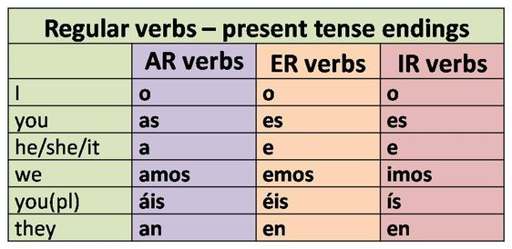

4. PRÁCTICA ESCRITA – Written practice! Say the present and future tense and find out which verb to use.

Ex. Yo/ escuela---- Yo estoy en la escuela. ----Yo voy a estar en la escuela mañana.
present future

 | Present Tense | Future “voy” conjugation
- Él / campo
- Ella / Universidad

- Nosotros / caballo

- Ellos / algunos animales

- Usted / Arquitecto

- Ellos / a la playa

- Yo / un coche

5. More Conversation Practice! - ¡Vamos a conversar! Review the conversation from the PowerPoint visual and ensure that participants understand the questions and answers. *Remember to see the note from Day 1 related to breakout rooms.

6. Vocabulary #3. LOS ADVERBIOS -Adverbs. Vamos a aprender el verbo IR -to go y su conjugación para hablar del futuro. We are going to learn the verb IR -to go and its conjugation to talk about the future.

What Is an Adverb?
By definition, adverbs are invariable words that modify verbs, adjectives and other adverbs. This is very important to remember since adverbs never modify nouns (you cannot say rápidamente libro — quickly book, but you can say levantarse rápidamente — to get up quickly).

There are different groups of adverbs and each of them answers different specific questions.

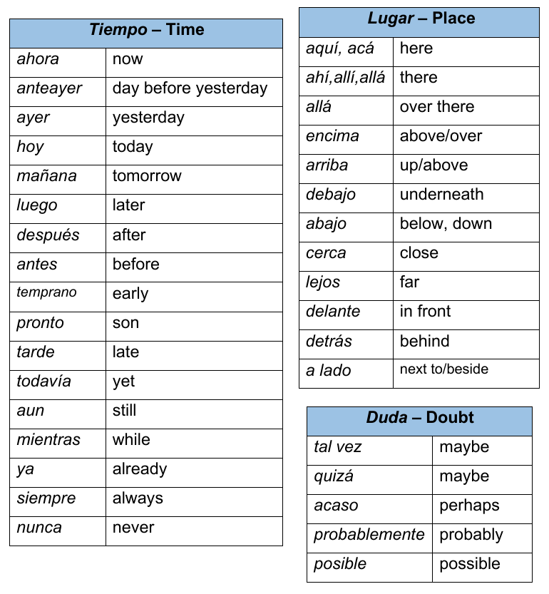
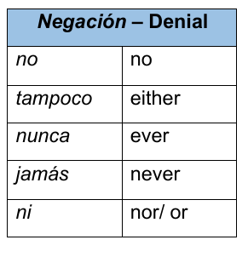
TIPOS DE ADVERBIOS/ TYPES OF ADVERBS

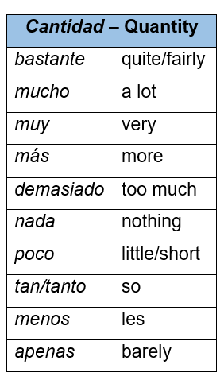
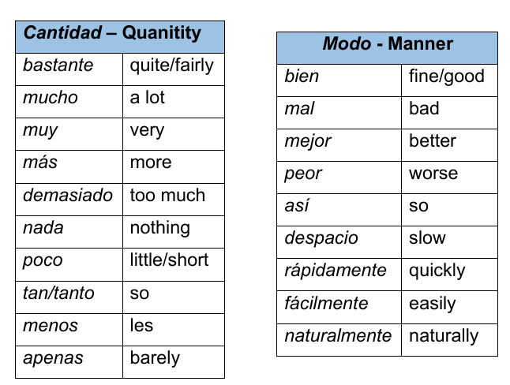
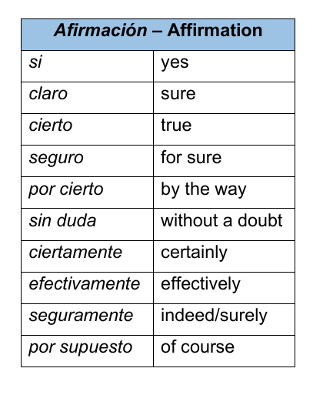

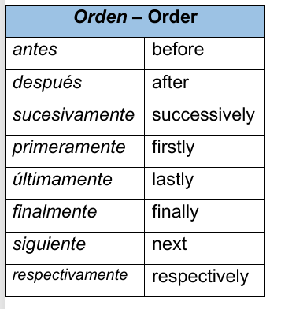

7. Los Adverbios – Adverbs: How to form them in Spanish?
Click HERE to practice online with flashcards and interactive games on Quizlet:
Every Spanish word that ends in -mente is an adverb, equivalent to -ly in English.
MENTE
Adjective in
FEMININE

Put any adjective in feminine form and add the MENTE ending as follows:
lento | slow | lentamente | slowly
silencioso | silent | silenciosamente | quietly
misterioso | mysterious | misteriosamente | mysteriously
violento | violent | violentamente | violently
*If there is no feminine form, we still add the mente ending
fuerte | strong | fuertemente | strongly
valiente | brave | valientemente | bravely
inteligente | smart | inteligentemente | smartly

8. More Conversation Practice! - ¡Vamos a conversar! Review the conversation from the PowerPoint visual and ensure that participants understand the questions and answers. *Remember to see the note from Day 1 related to breakout rooms.

9. EXTRA. Información Útil: Los Adverbios – Useful information about Adverbs: Placement
The placement of Spanish adverbs can be difficult. Whereas in English their placement is sometimes arbitrary (they might be found before or after the verb, or even at the beginning or end of the sentence), the placement rules for Spanish adverbs are much stricter.
- When a Spanish adverb is modifying a verb, it is placed after the verb.
Comimos bien esta mañana……… ……We ate well this morning.
Los libros llegaron afortunadamente…… The books arrived, fortunately.

Practice: Write down your Spanish answers. Then try to say each sentence out loud:
- We slept (dormimos) bad last night. ____________________________________________________
- We ate (comimos) delicious! __________________________________________________________
- You work a lot! _____________________________________________________________________
- She walks slowly! ___________________________________________________________________
- They wake up late. __________________________________________________________________

- An adverb cannot be placed in between two verbs or between an auxiliary verb and main verb; it is placed after both of them.

Vamos a comer bien……………We’re going to eat well.

Has aprendido rápidamente…. You have learned quickly. OR You have quickly learned.
Practice: Write down your Spanish answers. Then try to say each sentence out loud:
- We will drive (manejar) slowly. ________________________________________________________
- He will go to exercise (hacer ejercicio) hard. ______________________________________________
- She learns (aprender) fast. ____________________________________________________________
- She walks (caminar) and breaths (respirar) slowly! _________________________________________
- I like to sleep (dormir) deeply. __________________________________________________________

- When an adverb is modifying an adjective or another adverb, it is placed in front of the word it is modifying.
Comimos muy bien. |  | We ate very well.
Sus ideas son completamente locas. |  | His ideas are completely crazy.

Practice: Write down your Spanish answers. Then try to say each sentence out loud:
- We arrived very late. _____________________________________________________________
- They are very young. _____________________________________________________________
- The gas is too expensive. __________________________________________________________
- Traveling is so much fun. __________________________________________________________
- Your dress is completely dirty. ______________________________________________________
There are more rules to the placement and uses of Spanish adverbs, but these three apply to the majority of situations.

10. OPTIONAL TAREA /Homework. Encourage participants to use the Quizlet links provided in their handout to review the material covered in today’s lesson. Please, remind them that they can access Futura’s portal to review the lesson with the visuals and other materials as well.

