Student Resource Page. CUMPLEAÑOS Y FECHAS – BIRTHDAYS AND DATES
cumpleaños | birthday | velas /velitas | candles
feliz | happy | baile (bailar) | dance
feliz cumpleaños | happy birthday | globos | balloons
fiesta | party | dulces | candy
amigos | friends | *piñata | piñata
familia | family | cumpleañero | birthday boy
helado | ice cream | cumpleañera | birthday girl
invitaciones | invitations | fecha | date
regalos | presents | años | years old
pastel /torta | cake | gracias | thank you

NOTA CULTURAL:
Have you ever been in a birthday party where they “break a piñata”? Piñatas are a popular tradition in many Latin American countries.
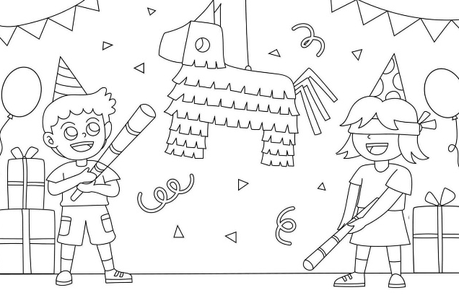
A piñata is a colorful container, usually made of paper and cardboard, that is filled with candy and small toys. It is often shaped like an animal, star, or fun character.
At parties, especially birthdays, children take turns trying to break the piñata with a stick while blindfolded. When it breaks, the candy falls out and everyone collects it.

¡Qué divertido! How fun!

REVIEW! Numbers 1-31 (calendar days)
1 | For dates we use the word primero, which means first.
2 | dos | 17 | diecisiete
3 | tres | 18 | dieciocho
4 | cuatro | 19 | diecinueve
5 | cinco | 20 | veinte
6 | seis | 21 | veintiuno
7 | siete | 22 | veintidós
8 | ocho | 23 | veintitrés
9 | nueve | 24 | veinticuatro
10 | diez | 25 | veinticinco
11 | once | 26 | veintiséis
12 | doce | 27 | veintisiete
13 | trece | 28 | veintiocho
14 | catorce | 29 | veintinueve
15 | quince | 30 | treinta
16 | dieciséis | 31 | treinta y uno

Optional vocabulary:

¿Cuándo es tu cumpleaños? /When is your birthday?

- Mi cumpleaños es en el mes de_____________________ de ________________________.
(number) (your birthday month)

¿Qué fecha es hoy? /What date is today?

-Hoy es _________________________________ de _____________________________.
(number) (month)

Variation with days of the week:

¿Qué fecha es hoy? /What date is today?

-Hoy es ___________________, ______________________ de ____________________.
(day of the week) (number) (month)

