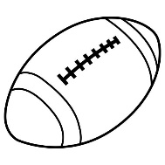
Student Resource Page 1. LOS DEPORTES – SPORTS

jugar | to play | el fútbol | soccer
el fútbol americano | american football | el golf | golf
la natación | swimming | la gimnasia | gymnastics
el tenis | tennis | el béisbol | baseball
el básquetbol /el baloncesto | basketball | el patinaje | skating
el karate | karate | el judo | judo
el boxeo | boxing | el ping pong | ping-pong
el esquí | skiing | el hockey | hockey
el boliche | bowling | el volibol /el voleibol | volleyball
la pesca /pescar | fishing | el pescado | fish (caught)

Material /equipo deportivo
un palo | a stick | una raqueta | a racquet
la pelota | ball (small) | el balón | ball (large)
un bate | a bate | los uniformes | uniforms
los bolos | bowling pins | los cascos | helmets

Más vocabulario
un aficionado /  una aficionada | a male fan  a female fan | un equipo | a team
un deporte | a sport | un deporte de equipo | a team sport
un deporte individual | an individual sport | un jugador /  una jugadora | a male player  a female player
un partido | a game | un estadio | a stadium
una cancha de tenis | a tennis court | un gimnasio | a gymnasium
un atleta /  una atleta | a male athlete  a female athlete | el campeón  la campeona | a male champion  a female champion


Optional vocabulary:

Me gusta ___________________________________________. (sport)
No me gusta ________________________________________. (sport)

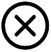
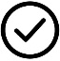
¿Te gusta el/la__________________________________________? (sport)
Sí me gusta____________________. No, no me gusta__________________.

Para jugar a la /al________________________, necesito_________________________.
(sport) (object)

Hay _________________ jugadores en un equipo de _____________________________.
(number) (object)

NEW! Verbo “jugar” – to play
yo juego | I play | nosotros jugamos | we play
tú juegas | you play (informal) | vosotros jugáis | you all play (informal)  *Used only in Spain
ella juega | she plays | ellos juegan | they play  (all boys or boys and girls together)
él juega | he plays | ellas juegan | they play (all girls)
usted juega | you play (formal) | ustedes juegan | you all play (formal)

With what sports do you use the verb JUGAR in SPANISH?

American football
tennis
basketball
soccer
baseball

volleyball
bowling
golf
ping-pong
hockey

 | I play |  | we play
 | you play (informal) |  | you all play (informal)  *Used only in Spain
 | she plays |  | they play  (all boys or boys and girls together)
 | he plays |  | they play (all girls)
 | you play (formal) |  | you all play (formal)
JUGAR: Write down the verb conjugations in Spanish. Use your student resource page to help you!

Translate the following sentences into Spanish. Use your Student Resource Pages to help you!
I play soccer. _______________________________________________________________________
You play (informal) American football.
_______________________________________________________________________
She plays tennis.
_______________________________________________________________________
He plays basketball.
_______________________________________________________________________
You (informal) bowl (play bowling).
_______________________________________________________________________
We play baseball.
_______________________________________________________________________
You all (informal) play golf.
_______________________________________________________________________
They play (all boys) hockey.
_______________________________________________________________________
You all (formal) play pin-pong.
_______________________________________________________________________
They play (all girls) volleyball.
_______________________________________________________________________
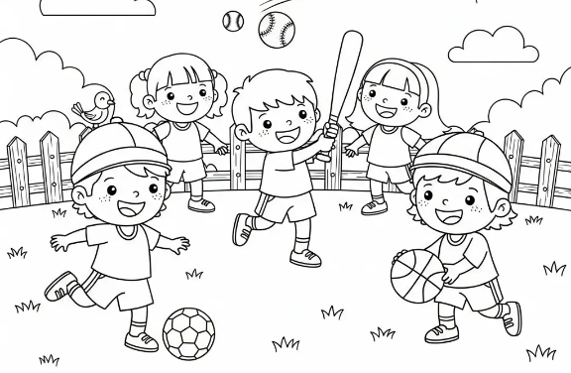

NEW! Verbo “practicar” – to practice
yo practico | I practice | nosotros practicamos | we practice
tú practicas | you practice (informal) | vosotros practicáis | you all practice (informal)  *Used only in Spain
ella practica | she practices | ellos practican | they practice  (all boys or boys and girls together)
él practica | he practices | ellas practican | they practice (all girls)
usted practica | you practice (formal) | ustedes practican | you all practice (formal)

With what sports do you use the verb PRACTICAR in SPANISH?

swimming
karate

boxing
gymnastics

skating
judo

fishing
skiing
PRACTICAR: Write down the verb conjugations in Spanish. Use your student resource page to help you!

 | I practice |  | we practice
 | you practice (informal) |  | you all practice (informal)  *Used only in Spain
 | she practices |  | they practice  (all boys or boys and girls together)
 | he practices |  | they practice (all girls)
 | you practice (formal) |  | you all practice (formal)

Translate the following sentences into Spanish. Use your Student Resource Pages to help you!
I practice swimming. _______________________________________________________________________
You practice (informal) karate.
_______________________________________________________________________
She practices gymnastics.
_______________________________________________________________________
He practices boxing.
_______________________________________________________________________
You practice (informal) skating.
_______________________________________________________________________
We practice judo.
_______________________________________________________________________
You all (informal) practice fishing.
_______________________________________________________________________
They practice (all boys) skiing.
_______________________________________________________________________
You all (formal) practice swimming.
_______________________________________________________________________
They practice (all girls) karate.
_______________________________________________________________________
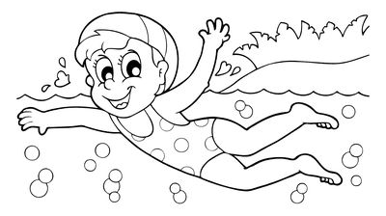
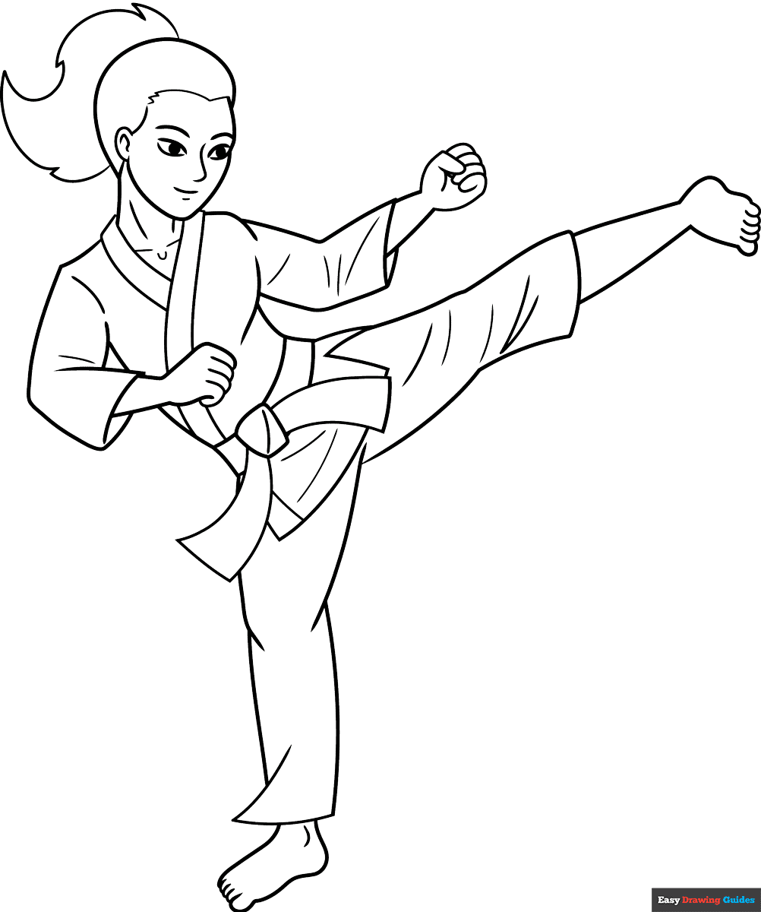
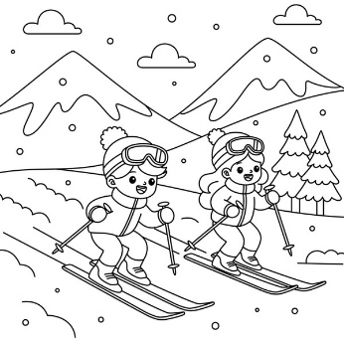
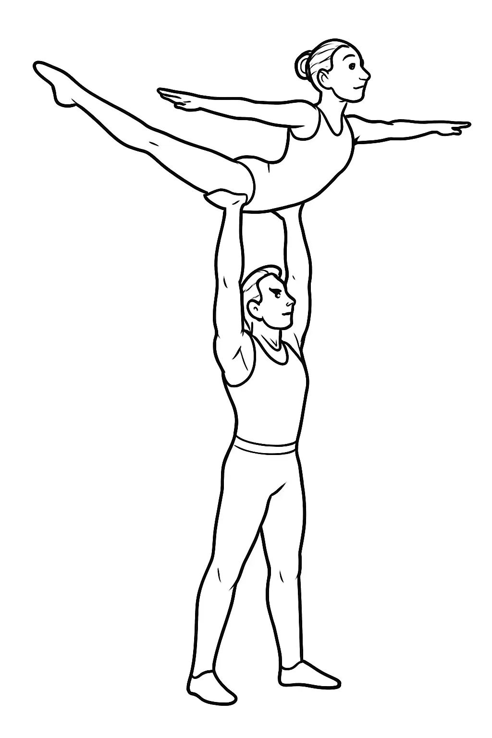

REPASO /REVIEW:
Los Pronombres – Subject Pronouns

yo | I | nosotros/as | we
tú | you (informal) | vosotros/as | you all (informal)  *Used only in Spain
ella | she | ellos | they (all boys or boys and girls together)
él | he | ellas | they (all girls)
usted | you (formal) | ustedes | you all (formal)

